14/April/2026


17/April/2026
Vendor Update Flow
Pidilite
Prepared By Manch Technology

Version History
VERSION | Reviewed By | Draft Shared Date | DESCRIPTION OF CHANGE | AUTHOR
1.0 |  | 14/April/2026 |  | Sonal Joseph

1. Executive Summary 3
1.1 Purpose 3
1.2 Audience 3
2. Project Description 3
2.1 Background 3
2.2 Objectives 3
3. Project Scope 4
3.1 In Scope 4
3.2 Out of Scope 4
4. Vendor Update Functional Requirements 5
4.1 Flow Chart 5
4.2 Manch Terminology Reference 6
4.3 Initiation Methods 6
4.4 Field-Level Information 7
4.5 Process Details 43
4.5.1 Initiator Behaviour 43
4.5.2 Vendor Behaviour 51
4.5.3 Approver Behaviour 56
4.5.3.1 Approver Flow for Vendor Update Domestic 57
4.5.3.1.1 Approver Flow for Vendor Update Domestic – Critical Field 57
4.5.3.2 Approver Flow for Vendor Update Domestic – Non-Critical 59
4.5.3.3 Approver Flow for Vendor Update Import 59
4.5.3.4 Approver Flow for Vendor Update Import – Non-Critical 61
4.6 Reference Tables 61
4.7 Record List View 64
4.8 MASS VENDOR UPDATE THROUGH BULK DATA UPLOAD 64
4.9 Communication Requirements 65
4.9.1 Communication Channels 65
4.10 Reporting Requirements 66
4.11 Integration Requirements 66
4.11.1 Integration Overview 66
5. DEPENDENCIES AND QUERIES 66
6. Appendix 67
7.TO BE CONSIDERED IN PHASE TWO 67

1. Executive Summary

1.1 Purpose
This Business User Document describes the requirements for standardizing and automating the vendor creation process within the organization. It aims to ensure that vendor master data is captured accurately, approved efficiently, and made available in downstream systems in a timely and compliant manner.

1.2 Audience
The primary audience of this document includes business owners for procurement and finance, business analysts, project managers, solution architects, developers, and key end-users involved in vendor onboarding and maintenance. It may also be referenced by internal audit, compliance, and operations teams to validate that the implemented process aligns with policy and regulatory requirements.

2. Project Description

2.1 Background
The following sections outline the structured workflow for the Vendor Update process, detailing each stage from initiation through to final approval. This formalized approach is designed to ensure clarity, accuracy, and consistency at every step, thereby facilitating a seamless and transparent experience for all stakeholders involved.

2.2 Objectives
The project aims to design and implement a controlled, workflow-driven vendor update process that enforces mandatory data fields, documentation checks, and role-based approvals. It also seeks to improve transparency and auditability through clear status tracking, standardized communications, and integration with the organization’s master data and finance systems.

3. Project Scope

3.1 In Scope

- Capture and validation of vendor master data through a standardized vendor creation form (internal and external-facing).
- Workflow for vendor update request , review, and approval, and compliance as applicable.
- Storage and verification of mandatory supporting documents (e.g., tax, banking, registration, and compliance certificates).
- Creation and update of vendor records in the target ERP/procurement system, including basic integration or interface design.
- Basic reporting and dashboards for tracking vendor requests, status and turnaround times.

3.2 Out of Scope
- Changes to core ERP configuration.
- Advanced vendor performance management, risk scoring, and contract lifecycle management functionalities.
- Decommissioning or redesign of unrelated procurement processes (e.g., purchase requisition, purchase order, or invoicing flows).
- Implementation of third-party systems.

4. Vendor Update Functional Requirements

4.1 Flow Chart

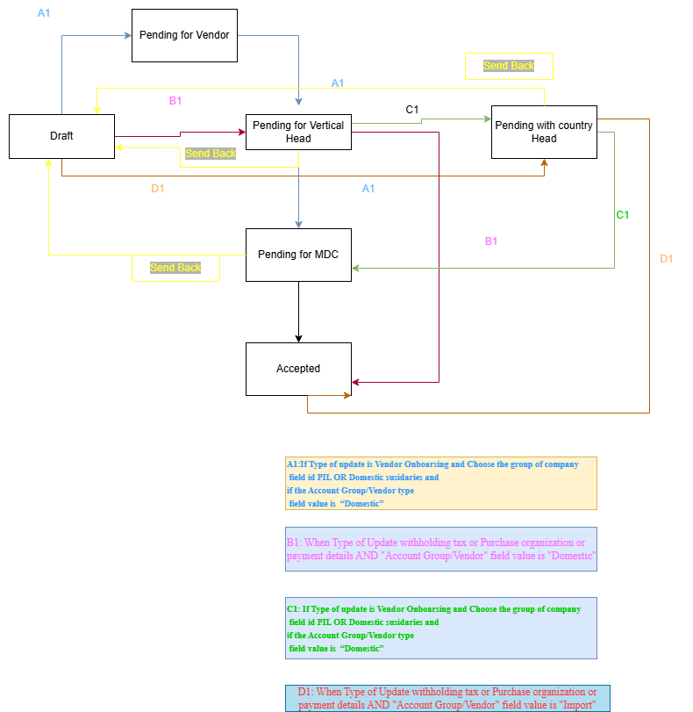

4.2 Manch Terminology Reference
BUD Terminology | Manch Terminology
Requestor / Initiator Behaviour | First Party Behaviour
Vendor Behaviour | Second Party Behaviour
Approver / Contributor Behaviour | Approver or Template Participants Behaviour

4.3 Initiation Methods

- Login: The Pidilite team accesses the Manch application using the SSO Login.

- Request Initiation: The initiator clicks on "Create" and selects "Request." They must then choose the process type as “Vendor Update” and proceed to start the vendor change request.

4.4 Field-Level Information

Field Name | Field Type | Mandatory | Logic
Basic Details | PANEL | No
Vendor Code and Name | DROPDOWN | Yes | The dropdown value should be a concatenation of the first and third Attribute from the staging data “VC_BASIC_DETAILS”  The dropdown should be searchable.
Vendor Code | Text | Yes | Copy only the vendor code from field name “Vendor Code and Name”
Vendor Name | Text | Yes | Auto fetch based on search Vendor Name or Code from Reference Table-  VC_BASIC_DETAILS attribute 3
Type of Update | MULTISELECT_EXTERNAL_DROPDOWN | Yes | This is a dropdown field data uploaded in “TYPE_OF_UPDATE” EDV.  Dropdown Values:  1)Vendor Onboarding  2)Withholding Tax Details  3)Purchase Organization and Payment Details
Created on | DATE | No | The request creation date will be auto-derived from setdate rule (Non-editable)
Company and Ownership | TEXT | No | Derived this field value as attribute 18  “VC_BASIC_DETAILS” Staging based on Vendor Code Field value which is attribute 1
Choose the Group of Company | TEXT | No | Derived this field value as attribute 19  “VC_BASIC_DETAILS” Staging based on Vendor Code Field value which is attribute 1
Account Group/Vendor Type | TEXT | No | Derived this field value as attribute 20  “VC_BASIC_DETAILS” Staging based on Vendor Code Field value which is attribute 1
Vendor Domestic or Import | TEXT | No | Derived this field value as attribute 21  “VC_BASIC_DETAILS” Staging based on Vendor Code Field value which is attribute 1
Mobile Number | TEXT | No | Free text field to enter the Mobile Number
Group key/Corporate Group | Dropdown |  | Derived this field value as attribute  16 “VC_BASIC_DETAILS” Staging based on Vendor Code Field value which is attribute 1
Mobile Number Update | PANEL | No
Existing Mobile Number | TEXT | No | Derived this field value as attribute 12 of “  “VC_CONTACT_DETAILS” Staging based on Vendor Code (from Basic Details panel) Field value which is attribute 1
Mobile Number | TEXT | No | Copy the “Mobile Number” (from Basic Details panel) Field data from the basic details panel,make this field as disabled.This field should have 10 digit Mobile validation.
Mobile Number OTP | TEXT | Yes | mandatory if Mobile Number OTP is triggered and is editable
Mobile Number/Telephone Number | TEXT | No | Field Length is 15 digit and only numeric value are allowed in this field
Email ID Update | PANEL | No
Existing Email | TEXT | No | Derived this field value as attribute 12 of “  “VC_EMAIL_DETAILS” Staging based on Vendor Code Field (from Basic Details panel) value which is attribute 1 in this staging.
Email ID | TEXT | No | Requestor enters the new email ID.Email ID validation to be applied maximum length of this field is 256.
Name, GSTIN and PAN Update | PANEL | No
Existing Name/ First Name of the Organization | TEXT | No | Derived this field value as attribute 3 of “VC_BASIC_DETAILS ” Staging based on Vendor Code Field (from Basic Details panel) value which is attribute 1 in this staging.
New Name/ First Name of the Organization | TEXT | Yes | Free text to entered by Inititator
PAN Details | label
Existing PAN | TEXT | No | Derived this field value as attribute 8 of “VC_BASIC_DETAILS ” Staging based on Vendor Code (from Basic Details panel) Field value which is attribute 1 in this staging.
Upload PAN | FILE | No | Max size limit of the file to upload is 15 MB.
Permanent Account Number | TEXT | No | PAN Validation rule based on the number. Derive Name,Type,Status, It should be upper case field. Apply PAN with GST match rule
Pan Holder Name | TEXT | No | It should be upper case field and non-editable, Data will come from PAN validation.
PAN Type | TEXT | No | It should be upper case field and non-editable, Data will come from PAN validation.
PAN Status | TEXT | No | It should be upper case field and non-editable, Data will come from PAN validation.
ID Type | TEXT | No | The "ID Type" field's default value is set to "ZCUCIN" only if the "PAN Type" field is "Company." Otherwise, the "ID Type" field will remain blank and Invisible.
GST Details | Label | No
Existing GST Number | TEXT | No | Derived this field value as attribute 7 of “VC_BASIC_DETAILS ” Staging based on Vendor Code (from Basic Details panel) Field value which is attribute 1 in this staging.
Please select GST option | DROPDOWN | Yes | Dropdown fetched from “GSTVALUE” EDV Attribute 1  Dropdown values  - GST Registered  - SEZ  - SEZ Unit  - SEZ Developer  - Special Economic  - Composition Scheme  - GST Not Registered
Upload GSTIN | FILE | Yes | - GST Registered  - SEZ  - SEZ Unit  - SEZ Developer  - Special Economic  - Composition Scheme  The maximum file size limit is 15MB, which will require validation.
GSTIN | TEXT | No | - GST Registered  - SEZ  - SEZ Unit  - SEZ Developer  - Special Economic  - Composition Scheme
Trade Name | TEXT | No | If the field "Please select GST option" values is selected other than “GST Non Registered” then Trade Name field will be visible otherwise invisible. This should be non-mandatory and non-editable. Data will come from GSTIN verification.
Legal Name | TEXT | No | If the field "Please select GST option" values is selected other than “GST Non Registered” then the Legal Name field will be visible otherwise invisible. This should be non-mandatory and non-editable. Data will come from GSTIN verification.
Reg Date | TEXT | No | If the field "Please select GST option" values is selected other than “GST Non Registered” then Reg Date field will be visible otherwise invisible. This should be non-mandatory and non-editable. Data will come from GSTIN verification.
City | TEXT | No | If the field "Please select GST option" values is selected other than “GST Non Registered” then City field will be visible otherwise invisible. This should be non-mandatory and non-editable. Data will come from GSTIN verification.
Type | TEXT | No | If the field "Please select GST option" values is selected other than “GST Non Registered” then Type field will be visible otherwise invisible. This should be non-mandatory and non-editable. Data will come from GSTIN verification.
Building Number | TEXT | No | If the field "Please select GST option" values is selected other than “GST Non Registered” then Building Number field will be visible otherwise invisible. This should be non-mandatory and non-editable. Data will come from GSTIN verification.
District Code | TEXT | No | If the field "Please select GST option" values is selected other than “GST Non Registered” then District Code field will be visible otherwise invisible. This should be non-mandatory and non-editable. Data will come from GSTIN verification.
State Code | TEXT | No | If the field "Please select GST option" values is selected other than “GST Non Registered” then State Code field will be visible otherwise invisible. This should be non-mandatory and non-editable. Data will come from GSTIN verification.
Street | TEXT | No | If the field "Please select GST option" values is selected other than “GST Non Registered” then Street field will be visible otherwise invisible. This should be non-mandatory and non-editable. Data will come from GSTIN verification.
Pin Code | TEXT | No | If the field "Please select GST option" values is selected other than “GST Non Registered” then Pin Code field will be visible otherwise invisible. This should be non-mandatory and non-editable. Data will come from GSTIN verification.
Building Name | TEXT | No | If the field "Please select GST option" values is selected other than “GST Non Registered” then Building Name field will be visible otherwise invisible. This should be non-mandatory and non-editable. Data will come from GSTIN verification.
Flat Number | TEXT | No | If the field "Please select GST option" values is selected other than “GST Non Registered” then Flat Number field will be visible otherwise invisible. This should be non-mandatory and non-editable. Data will come from GSTIN verification.
Nature of Business | TEXT | No | If the field "Please select GST option" values is selected other than “GST Non Registered” then Nature of Businessfield will be visible otherwise invisible. This should be non-mandatory and non-editable. Data will come from GSTIN verification.
GSTIN Declaration | LABEL | No | invisible and Non-Mandatory.
Upload Declaration | FILE | No | this field is non mandatory.  File size should be up to 15 Mb.
GST Vendor Classification | Text | No | Auto fetch from “GSTVALUE” EDV from Attribute 2. This field will be always invisible.  Add Regex validation numeric only
Is your Primary address the same as your GST Principal address? | Dropdown | No | Dropdown values YesNo
Address Details Update | PANEL | No
Please Choose Address Proof | DROPDOWN | Yes | Dropdown values are stored  “ADDRESS_PROOF" EDV.  Attribute1  - The "Group of company" (from Basic Details panel) field value is "PIL" or "Domestic subsidiaries".  - The "Vendor Domestic/Import" (from Basic Details panel) field value is "Domestic".
Aadhaar Front Copy | FILE | No
Aadhaar Back Copy | FILE | No
Electricity bill | FILE | No | Visible and Mandatory if 'Electricity bill copy upload' is chosen
Existing Street | TEXT | Yes | Derived this field value as attribute 36 of “VC_ADDRESS_DETAILS ” Staging based on ADDRNUMBER Field value which is attribute 1 in this staging. `
New Street | TEXT | Yes | If "Is your Primary address same as GST Principal address?" (from Name, GSTIN and PAN Update panel) is selected as Yes, then address will be automatically populated based on the GST address.If No is selected, then field becomes editable, allowing for manual data entry.  The max length is 140 alphanumeric and its a mandatory field
Existing Street 1 | TEXT | No | Derived this field value as attribute 43 of “VC_ADDRESS_DETAILS ” Staging based on ADDRNUMBER Field value which is attribute 1 in this staging. Non Editable
New Street 1 | TEXT | Yes | The first 60 char length from “New street” field will be copied to “New Street 1” field
Existing Street 2 | TEXT | No | Derived this field value as attribute 44 of “VC_ADDRESS_DETAILS ” Staging based on ADDRNUMBER Field value which is attribute 1 in this staging.  This is a Non editable field
New Street 2 | TEXT |  | The next 40 char length from “New street” field will be copied to “New Street 2” field
Existing Street 3 | TEXT | No | Derived this field value as attribute 45 of “VC_ADDRESS_DETAILS ” Staging based on ADDRNUMBER Field value which is attribute 1 in this staging.  This is a Non editable field
New Street 3 | TEXT | No | The next 40 char length from “New street” field will be copied to “New Street 3” field
Existing Postal Code | TEXT |  | Derived this field value as attribute 5 of " “VC_BASIC_DETAILS " ” Staging based on Vendor code (from Basic Details panel) Field value which is attribute 1 in this staging.
New Postal Code | TEXT | No | The information is visible to vendors only when the " choose the group of company" field (from Basic Details panel) from Basic details Panel is selected as "PIL" or "Domestic Subsidiaries" AND the "Vendor Domestic/Import" field (from Basic Details panel) is selected as "Domestic."  Postal Code verification will be performed after manual entry.  Add Regex validation Numeric only
New Postal Code(Domestic) | TEXT | No | Add Regex validation Numeric only
Existing City | TEXT | No | Derived this field value as attribute 15 of “VC_ADDRESS_DETAILS ” Staging based on ADDRNUMBER Field value which is attribute 1 in this staging.  This is a Non editable field
New City | TEXT | No | if choose the group of company (from Basic Details panel) is International subsidiaries or Domestic subsidiaries and Vendor Domestic/Import field (from Basic Details panel) value is Import then this field will be manual entered
Existing District | TEXT | No | Derived this field value as attribute 1 of “VC_ADDRESS_DETAILS ” Staging based on ADDRNUMBER Field value which is attribute 1 in this staging.  This is a Non editable field
New District | TEXT | No | if " “choose the group of company " (from Basic Details panel) ” is PIL or " “Domestic and Vendor Domestic/Import " (from Basic Details panel) ” field as Domestic value this will be fetched from Pincode derivation.  if choose the group of company (from Basic Details panel) is International subsidiaries or Domestic subsidiaries and Vendor Domestic/Import (from Basic Details panel) is Import then this field will be manual entered
Existing Region | TEXT | No | Derived this field value as attribute 6 of " “VC_BASIC_DETAILS " ” Staging based on vendor code (from Basic Details panel) Field value which is attribute 1 in this staging.  This is a Non editable field
Supplier Country | DROPDOWN |  | Refer " ” COUNTRY " ” EDV attribute1.
New Region | DROPDOWN | No | if " “choose the group of company " (from Basic Details panel) ” field have value " “International subsidiaries " ” or " “Domestic subsidiaries " ” and " “Vendor Domestic/Import " (from Basic Details panel) ” field as the value,then this field will be visible if not invisible.  And based on supplier country values are that is fetch attribute 5 based on attribute1 Refer " ” COUNTRY " ” EDV
Country | DROPDOWN | No
Bank Details Change | PANEL | No
Please choose the option | DROPDOWN | Yes | This values are fetched from the below EDV  “BANK_OPTIONS”  Dropdown Values  - Cancelled Cheque Image  - Passbook  - Bank Statement/Confirmation Image  - Cheque (Import)
Cancelled Cheque Image | File | No | If " “Please choose the option " ” field is selected as cancelled cheque image then this file upload will be visible and mandatory.Otherwise invisible and non mandatory.This option is enabled when the "choose the group of company" (from Basic Details panel) field from Basic details Panel is set to PIL or Domestic Subsidiaries, AND the " “Account group/Vendor " (from Basic Details panel) ” field has a value of Domestic.
Passbook | File | No | If " “Please choose the option " ” field is selected as Passbook then this file upload will be visible and mandatory.Otherwise invisible and non mandatory.This option is enabled when the "choose the group of company" (from Basic Details panel) field from Basic details Panel is set to PIL or Domestic Subsidiaries, AND the " “Account group/Vendor " (from Basic Details panel) ” field has a value of Domestic.
Bank Statement/Confirmation Image | File | No | If Please choose the option in the dropdown if you have selected Bank Statement/Confirmation Image then this file upload will be visible and made mandatory.  Otherwise invisible and non mandatory.  The option will only be displayed if:  - The "Group of company" (from Basic Details panel) field is set to either "Domestic Subsidiaries" or "International Subsidiaries."  - The "Account group/Vendor" (from Basic Details panel) field has a value of "Import."
Cheque (Import) | File | No | If Please choose the option in the dropdown if you have selectedCheque (Import) then this file upload will be visible and made mandatory.  Otherwise invisible and non mandatory.  The option will only be displayed if:  - The "Group of company" (from Basic Details panel) field is set to either "Domestic Subsidiaries" or "International Subsidiaries."  - The "Account group/Vendor" (from Basic Details panel) field has a value of "Import."
Existing Bank Account Number | TEXT | No | Derived this field value as attribute 3 of " “VC_BANK_DETAILS " ” Staging based on Vendor code (from Basic Details panel) Field value which is attribute 1 in this staging.  This is a Non editable field
Bank Account Number(Domestic) | TEXT | Yes | Cheque OCR fetches the bank account number Non Editable field. This field will be visible only if cheque image is selected and made non editable,If Passbook was selected this field will be editable and and visible.
Bank Account Number | TEXT | Yes | This field will be visible if dropdown option is selected as Cheque (Import) or Bank Statement/Confirmation Image and this is a manual entry field
Existing IFSC Code / SWIFT Code / Bank Key | TEXT | No | Derived this field value as attribute 2 of " “VC_BANK_DETAILS " ” Staging based on Vendor code (from Basic Details panel) Field value which is attribute 1 in this staging.  This is a Non editable field
IFSC Code | TEXT | Yes | Cheque OCR fetches the IFSC Code Non Editable field; this field will be visible only if cheque image is selected and made non editable,If Passbook was selected this field will be editable and and visible.
IFSC Code / SWIFT Code / Bank Key | TEXT | Yes | This field will be visible if dropdown option is selected as Cheque (Import) or Bank Statement/Confirmation Image and this is a manual entry field
Existing Bank Holder Name | TEXT | No | Derived this field value as attribute 40of " “VC_BANK_DETAILS " ” Staging based on Vendor code (from Basic Details panel) Field value which is attribute 1 in this staging.  This is a Non editable field
Name of Account Holder(Domestic) | TEXT | Yes | Auto-derived from bank Verify API which is done post cheque OCR captures Account number and IFSC Code validation happens and Name of account holder is fetched this is Non Editable field incase of Canceled Cheque Image and passbook is selected and hidden if its other then these 2 selection from dropdown
Name of Account Holder | TEXT | No | This field will be visible if dropdown option is selected as Cheque (Import) or Bank Statement/Confirmation Image and this is a manual entry field
Bank Name(Domestic | TEXT | Yes | Auto-derived from bank Verify API which is done post cheque OCR captures Account number and IFSC Code validation happens and Name of account holder is fetched this is Non Editable field incase of Canceled Cheque Image and passbook is selected and hidden if its other then these 2 selection from dropdown
Bank Name | TEXT | No | This field will be visible only if dropdown option is selected as Cheque (Import) or Bank Statement/Confirmation Image and this is a manual entry field
Bank Branch(Domestic) | TEXT | Yes | Auto-derived from bank Verify API which is done post cheque OCR captures Account number and IFSC Code validation happens and Name of account holder is fetched this is Non Editable field incase of Canceled Cheque Image and passbook is selected and hidden if its other then these 2 selection from dropdown
Bank Branch | TEXT | No | This field will be visible only if dropdown option is selected as Cheque (Import) or Bank Statement/Confirmation Image and this is a manual entry field
Bank Address(Domestic) | TEXT | No | Auto-derived from bank Verify API which is done post cheque OCR captures Account number and IFSC Code validation happens and Name of account holder is fetched this is Non Editable field incase of Canceled Cheque Image and passbook is selected and hidden if its other then these 2 selection from dropdown
Bank Address | TEXT | No | This field will be visible only if dropdown option is selected as Cheque (Import) or Bank Statement/Confirmation Image and this is a manual entry field
Bank Country(Domestic) | TEXT | No | If Please choose the option in the dropdown if you have selected canceled cheque image or passbook then this field will be visible with pre filled value as India if this is not the not the selection then its invisible and Non Mandatory.
Bank Country | DROPDOWN | No | This field will be visible if dropdown option is selected as Cheque (Import) or Bank Statement/Confirmation Image and the dropdown value “COUNTRY” EDV with attribute1
CIN and TDS Details Update | PANEL | No
CIN Certificate | FILE | Yes | GSTIN and PAN Update panel) is " “company " ”
Existing CIN Number | TEXT | No | Derived this field value as attribute 4 of " “VC_CIN_DETAILS " ” Staging based on Vendor code (from Basic Details panel) Field value which is attribute 1 in this staging.  This is a Non editable field
New CIN Number | TEXT |  | Once CIN File is uploaded OCR Fetches the CIN number keep this field editable if OCR fails we can entered manually
TDS Applicable (Yes/No) | DROPDOWN | Yes | Dropdown values are  Yes  No
TDS Certificate: | FILE | Yes | If "Yes" then TDS certificate upload field is mandatory and visible
MSME Update | PANEL | No | If the Type of update (from Basic Details panel) field value in " “Vendor Onboarding " ” then this Panel is visible to Vendor.
Is SSI / MSME Applicable? | DROPDOWN | Yes | Dropdown values YesNo
SSI / MSME Certificate Upload | FILE | No | If yes,Only in this case MSME upload will be mandatory .In case of No and deleting of the image all the fields should be cleared out
Existing SSI / MSME Number | TEXT | No | Derived this field value as attribute 23 of " “VC_BASIC_DETAILS " ” Staging based on Vendor code (from Basic Details panel) Field value which is attribute 1 in this staging.  This is a Non editable field
SSI / MSME Number | TEXT | No | Is SSI / MSME Applicable? Question is selected and yes and MSME image OCR is performed and Number is captured here and this field is kept editable just in case if MSME server fails
Name | TEXT | No | Auto-derived via SSI / MSME Validation (Non Editable)
Type | TEXT | No | Auto-derived via SSI / MSME Validation (Non Editable)
Address | TEXT | No | Auto-derived via SSI / MSME Validation (Non Editable)
Category | TEXT | No | Auto-derived via SSI / MSME Validation (Non Editable)
Date | TEXT | No | Auto-derived via SSI / MSME Validation (Non Editable)
Enterprise | TEXT | No | Auto-derived via SSI / MSME Validation (Non Editable)
Major Activity | TEXT | No | Auto-derived via SSI / MSME Validation (Non Editable)
Date of Commencement | TEXT | No | Auto-derived via SSI / MSME Validation (Non Editable)
Dic Name | TEXT | No | Auto-derived via SSI / MSME Validation (Non Editable)
State1 | TEXT | No | Auto-derived via SSI / MSME Validation (Non Editable)
Applied State | TEXT | No | Auto-derived via SSI / MSME Validation (Non Editable)
Modified Date | TEXT | No | Auto-derived via SSI / MSME Validation (Non Editable)
Expiry Date | TEXT | No | Auto-derived via SSI / MSME Validation (Non Editable)
Address Line1 | TEXT | No | Auto-derived via SSI / MSME Validation (Non Editable)
Building | TEXT | No | Auto-derived via SSI / MSME Validation (Non Editable)
Street | TEXT | No | Auto-derived via SSI / MSME Validation (Non Editable)
Area | TEXT | No | Auto-derived via SSI / MSME Validation (Non Editable)
City | TEXT | No | Auto-derived via SSI / MSME Validation (Non Editable)
Pin | TEXT | No | Auto-derived via SSI / MSME Validation (Non Editable)
State | TEXT | No | Auto-derived via SSI / MSME Validation (Non Editable)
District | TEXT | No | Auto-derived via SSI / MSME Validation (Non Editable)
Classification Year | TEXT | No | Auto-derived via SSI / MSME Validation (Non Editable)
Classification Date | TEXT | No | Auto-derived via SSI / MSME Validation (Non Editable)
MSME Declaration | FILE | No | If Is SSI / MSME Applicable?,
Payment Details | PANEL | No | This panel is visible to initiator if type of update (from Basic Details panel) is " “Purchase Organization update/Payment details " ”
Payment Methods | TEXT | Yes | This field is always invisible.If the bank Account number field (from Bank Details Change panel) is verified then populate " “N " ”, else " “C " ” as the value.
New House Bank | Text | No | Derived this field value as attribute 6 of " “COMPANY_CODE_PURCHASE_NEW " ” EDV based on attribute 1.  Field applicable only when " “choose the group of company field " (from Basic Details panel) ” is " “PIL " ” or " “Domestic Subsidiaries " ” and " “Account group/Vendor " ” field (from Basic Details panel) has Domestic  If company - 1000 - CIT01If company - 2000 - HDF01If company - 3000 - SBI09If company - 6000 - SBI01If company - 8000 - SCB01If company - 9000 - SCB01If company - F000 - SCB01If company - E000 - CIT01If company - B000 - CIT01If company - C000 - SCB01If company - H000 - CIT01
Existing Minority Indicator | TEXT | No | Derived this field value as attribute 38 of “VC_COMPANY_DETAILS ” EDV based on attribute 1 vendor code in this staging.
New Minority Indicator | TEXT | No | If the MSME Panel value is "Yes," and the "Category" (from MSME Update panel) field within the MSME Panel is either "MICRO" or "SMALL," then populate the "New Minority Indicator field" with the value "1." If the "Category" (from MSME Update panel) field is "MEDIUM," then use the value "2.".  If the "MSME Panel" value is "no":  - If the "Group Key" (from Basic Details panel) from Basic details Panel value is "utility," or, "Government vendor," or "directors vendor," use the default value 2.  - Otherwise, the default value is 5.  This field is only applicable when the process flow condition is if " “choose the group of company " (from Basic Details panel) ” field from Basic details Panel is PIL and Vendor Domestic/Import " (from Basic Details panel) ” field as Domestic value
Existing Reconciliation account | Text | No | Derived this field value as attribute 9 of “VC_COMPANY_DETAILS ” EDV based on attribute 1 vendor code in this staging.
Reconciliation Details | ARRAY_HDR | No
Company code | TEXT | NO | Refer EDV “COMPANY_CODE” Attribute1 for this dropdown field
Reconciliation account | DROPDOWN | Yes | Refer EDV “RECONCILIATIONACCOUNTNEW ” Attribute1 for this dropdown field
Reconciliation Details | ARRAY_END
Withholding Tax Details | PANEL | No
Is Withholding Tax Applicable? | DROPDOWN | No | Dropdown values  YesNo
Withholding Tax | ARRAY_HDR | No
Company Code | Text | No | Derived this field value as attribute 2 of “VC_WITHHOLDING_DETAILS ” based on attribute 1 vendor code in this staging.
Existing Withholding Tax Type | Text | No | Derived this field value as attribute 4 of “VC_WITHHOLDING_DETAILS ” based on attribute 1 vendor code in this staging.
New Withholding Tax Type | DROPDOWN | Yes | Dropdown values are fetched from the below EDV “PIDILITE_WITHHOLDING_TAX” attribute 2
Existing Subject to w/tax | CHECKBOX | No | Derived this field value as attribute 5 of “VC_WITHHOLDING_DETAILS ” based on attribute 1 vendor code in this staging.
Subject to w/tax | CHECKBOX | Yes | This is a mandatory field to be checked by Accounts Approver
Existing Recipient Type | TEXT | No | Derived this field value as attribute 6 of “VC_WITHHOLDING_DETAILS ” EDV based on attribute 1 vendor code in this staging.
Recipient Type | TEXT | No | If PAN Type (from Name, GSTIN and PAN Update panel) is company then Recipient type value to be fetched as " “CO " ” if other any company then value is " “OT " ”
Existing Withholding Tax Code | Text | No | Will be auto-derived from the Vendor Master Data based on vendor code (from Basic Details panel) selection (Non-Editable)
New Withholding Tax Code | DROPDOWN | Yes | Dropdown values are fetched from the below EDV “PIDILITE_WITHHOLDING_TAX” Attribut1
Withholding Tax | ARRAY_END |  | Table for multi selection will end here
All Financial & Bank Details are verified | CHECKBOX | Yes | This is a mandatory field to be checked by Accounts Approver
Concerned Email ID update | PANEL | No
Existing concerned Email Id | ARRAY_HDR
Existing Email ID | TEXT | No | This value will be fetched based on vendor code or name (from Basic Details panel) selection from the staging """ ””
Email ID | TEXT | No
Existing concerned Email Id | ARRAY_END | No
Additional Mobile number update | Panel | No | - Directors Payment  - Rent/ Subscription/ charges  - Govt Vendor  - Utility
Existing Contact Number 2  (Domestic) | Text | No
Contact Number 2(Domestic) | Text | No | This field is visible if " “AccountGroup/Vendor Type " (from Basic Details panel) ” Field as " “Domestic " ” as the value  Indian mobile validation of 9 digit
Existing Contact Number 3(Domestic) | Text | No
Contact Number 3(Domestic) | Text | No | This field is visible if " “AccountGroup/Vendor Type " (from Basic Details panel) ” Field as " “Domestic " ” as the value  Indian mobile validation of 9 digit
Existing Contact Number 4 (Domestic) | Text | No
Contact Number 4(Domestic) | Text | No | This field is visible if " “AccountGroup/Vendor Type " (from Basic Details panel) ” Field as " “Domestic " ” as the value  Indian mobile validation of 9 digit
Existing Contact Number 5(Domestic) | Text | No
Contact Number 5(Domestic) | Text | No | This field is visible if " “AccountGroup/Vendor Type " (from Basic Details panel) ” Field as " “Domestic " ” as the value  Indian mobile validation of 9 digit
Existing Contact Number 2 | Text | No
Contact Number2 | Text |  | This field is visible if " “AccountGroup/Vendor Type " (from Basic Details panel) ” Field as " “Domestic " ” as the value  Indian mobile validation of 9 digit
Existing Contact Number 3 | Text | No
Contact Number3 | Text | No | This field is visible if " “AccountGroup/Vendor Type " (from Basic Details panel) ” Field as " “Import " ” as the value  Indian mobile validation of 9 digit
Existing Contact Number 4 | Text | No | This field is visible if " “AccountGroup/Vendor Type " (from Basic Details panel) ” Field as " “Import " ” as the value  Indian mobile validation of 9 digit
Contact Number4 | Text | No | Validation is of 15 digits max
Existing Contact Number 5 | Text | No
Contact Number5 | Text | No | Validation is of 15 digits max
Purchase Organization Details | Panel | No
Purchase Organization | ARRAY_HDR
Existing Company Code | Text | No | Derived this field value as attribute 3 of " “VC_PURCHASE_DETAILS " ” Staging based on Vendor code (from Basic Details panel) Field value which is attribute 1 in this staging.  This is a Non editable field
Existing Purchase Organization | Text | No | Derived this field value as attribute 2 of " “VC_PURCHASE_DETAILS " ” Staging based on Vendor code (from Basic Details panel) Field value which is attribute 1 in this staging.  This is a Non editable field
Existing Order currency | Text | No | Derived this field value as attribute 10 of " “VC_PURCHASE_DETAILS " ” Staging based on Vendor code (from Basic Details panel) Field value which is attribute 1 in this staging. Non editable field
Existing Terms of Payment | Text | No | Derived this field value as attribute 14 of " “VC_PURCHASE_DETAILS " ” Staging based on Vendor code (from Basic Details panel) Field value which is attribute 1 in this staging. Non editable field
Existing Incoterms | Text | No | Derived this field value as attribute 15 of " “VC_PURCHASE_DETAILS " ” Staging based on Vendor code (from Basic Details panel) Field value which is attribute 1 in this staging.
Existing Incoterms (Part 2) | Text | No | Derived this field value as attribute 16 of " “VC_PURCHASE_DETAILS " ” Staging based on Vendor code (from Basic Details panel) Field value which is attribute 1 in this staging. Non editable field
Company Code | Text | No | Refer EDV “COMPANY_CODE” Attribute1 for this dropdown field
New Purchase Organization | DROPDOWN | Yes | The requestor will choose from the dropdown. Refer the dropdown “PURCHASE_ORG_DATA” EDV
New Order currency | DROPDOWN | Yes | The requestor will choose from the dropdown. Refer the EDV  “CURRENCY_COUNTRY”
New Terms of Payment | DROPDOWN | Yes | The requestor will choose from the dropdown. Refer the EDV  TERMS_OF_PAYMENT
New Incoterms | DROPDOWN | Yes | The requestor will choose from the dropdown. Refer the EDV  INCOTERMS
New Incoterms (Part 2) | Text | No | Copy the value from New Incoterms
Purchase Organization | ARRAY_END | No
Approver Mapping | PANEL | No | This panel is a invisible panel values will be fetched based on the login details and company code
Requestor Name | TEXT | Yes | Requester’s name will be auto-derived from the from created by name and by copying the value to here(Non-editable)
Requestor Email | TEXT | Yes | Requester’s email will be auto-derived from the from created by name and by copying the value to here(Non-editable)
Requestor Mobile Number | TEXT | Yes | Requester’s Mobile Number will be auto-derived from the from created by name and by copying the value to here(Non-editable)
Vertical Head Name | TEXT | No | “VENDORFLOWAPPROVERLOGICUPDATE” EDV fetech attribute 8 from Attribute 1
Vertical Head Email | TEXT | No | “VENDORFLOWAPPROVERLOGICUPDATE” EDV fetech attribute 9 from Attribute 1
Vertical Head Mobile | TEXT | No | “VENDORFLOWAPPROVERLOGICUPDATE” EDV fetech attribute 10from Attribute 1
Addition Of Approver | Panel | No | At the time of MDC Approver this panel will be visible
Do you want to send the request to Adhoc Approver? | DROPDOWN | Yes | Dropdown values  Yes  No  If Field Value Do you want to send the  request to Adhoc Approver?changes  then Clean and refreshes the field
Please choose  number of  Approver | DROPDOWN | No | This field will be visible and mandatory if  Yes is selected under “Do you want to  sent the request to Adhoc Approver?”  otherwise make it invisible and non  mandatory.  This values for this dropdown will be  fetched from : VENDORFLOWAPPROVERLOGICUPDATE  If Field Please choose number of  Approver values changes then clear and  refresh the Adhoc approver dropdown
Adhoc Approver1 Details | LABEL | No | Make it visible only if value 1/2/3/4/5 is selected  Under Please Choose Number of  Approvers
Adhoc Approver1 | DROPDOWN | No | Make it visible and mandatory only if  value 1 is selected under &quot;Please Choose  Number of Approvers  Values will be fetched from first column  of the EDV :  VENDORFLOWAPPROVERLOGICUPDATE
Adhoc Approver Name1 | TEXT | No | Value will be auto fetched from first  column of EDV :  VENDORFLOWAPPROVERLOGICUPDATE  Private and Confidential  Make it visible and mandatory only if  value 1 is selected under Please Choose  Number of Approvers
Adhoc Approver Email1 | TEXT | No | Value will be auto fetched from first  column of EDV :  VENDORFLOWAPPROVERLOGICUPDATE  Make it visible and mandatory only if  value 1 is selected under Please Choose  Number of Approvers
Adhoc Approver mobile number1 | TEXT | No | Value will be auto fetched from 7th  column of EDV :  VENDORFLOWAPPROVERLOGICUPDATE
Adhoc Approver 2 Details | LABEL | No | Make it visible only if value 2 is selected  under Please Choose Number of  Approvers
Adhoc Approver2 | DROPDOWN | No | Make it visible and mandatory only if  value 2 is selected under &quot;Please Choose  Number of Approvers  Values will be fetched from 6th column of  the EDV :  VENDORFLOWAPPROVERLOGICUPDATE  Adhoc Approver 1 will also be visible if  Value 2 is selected inPlease Choose  Number of Approvers
Adhoc Approver Name2 | TEXT | No | Value will be auto fetched from first  column of EDV :  VENDORFLOWAPPROVERLOGICUPDATE  Make it visible and mandatory only if  value 2 is selected under Please Choose  Number of Approvers
Adhoc Approver Email2 | TEXT | No | Value will be auto fetched from first  column of EDV :  VENDORFLOWAPPROVERLOGICUPDATE  Make it visible and mandatory only if  value 2 is selected under Please Choose  Number of Approvers.
Adhoc Approver mobile number2 | TEXT | No | Value will be auto fetched from 7th  column of EDV :  VENDORFLOWAPPROVERLOGICUPDATE  Make it visible and mandatory only if  value 2 is selected under.Please Choose  Number of Approvers
Adhoc Approver3 Details | LABEL | No | Make it visible only if value 3 is selected  under Please Choose Number of  Approvers
Adhoc Approver3 | DROPDOWN | No | Make it visible and mandatory only if  value 3 is selected under &quot;Please Choose  Number of Approvers&quot; .  Values will be fetched from 6th column of  the EDV :  VENDORFLOWAPPROVERLOGICUPDATE  Adhoc Approver 1, 2 will also be visible if  Value 3 is selected Please Choose  Number of Approvers
Adhoc Approver Name3 | TEXT | No | Value will be auto fetched from first  column of EDV :  VENDORFLOWAPPROVERLOGICUPDATE  Make it visible and mandatory only if  value 3 is selected under Please Choose  Number of Approvers
Adhoc Approver Email3 | TEXT | No | Value will be auto fetched from first  column of EDV :  VENDORFLOWAPPROVERLOGICUPDATE
Adhoc Approver mobile number3 | TEXT | No | &quot;Value will be auto fetched from 7th  column of EDV :  VENDORFLOWAPPROVERLOGICUPDATE  Make it visible and mandatory only if  value 3 is selected under Please Choose  Number of Approvers
Adhoc Approver4Details | LABEL | No | Make it visible only if value 4 is selected  under Please Choose Number of  Approvers
Adhoc Approver4 | DROPDOWN | No | Make it visible and mandatory only if  value 4 is selected under &quot;Please Choose  Number of Approvers&quot; .  Values will be fetched from 6th column of  the EDV :  VENDORFLOWAPPROVERLOGICUPDATE  Adhoc Approver 1,2,3 will also be visible if  Value 4 is selected in Please Choose  Number of Approvers
Adhoc Approver Name4 | TEXT | No | Value will be auto fetched from first  column of EDV :  VENDORFLOWAPPROVERLOGICUPDATE
Adhoc Approver Email 4 | TEXT | No | Value will be auto fetched from first  column of EDV :  VENDORFLOWAPPROVERLOGICUPDATE
Adhoc Approver mobile number4 | TEXT | No | Value will be auto fetched from 7th  column of EDV :  VENDORFLOWAPPROVERLOGICUPDATE
Adhoc Approver5 Details | LABEL | No | Make it visible only if value 5 is selected  Private and Confidential  Details under Please Choose Number of  Approvers
Adhoc Approver5 | DROPDOWN | No | Make it visible and mandatory only if  value 5 is selected under &quot;Please Choose  Number of Approvers Values will be fetched from 6th column of  the EDV :  VENDORFLOWAPPROVERLOGICUPDATE  Adhoc Approver 1,2,3,4 will also be visible  if Value 5 is selected in Please Choose  Number of Approvers
Adhoc Approver Name5 | TEXT | No | Value will be auto fetched from first  column of EDV :  VENDORFLOWAPPROVERLOGICUPDATE
Adhoc Approver Email5 | TEXT | No | Value will be auto fetched from first  column of EDV :  VENDORFLOWAPPROVERLOGICUPDATE
Adhoc Approver mobile number5 | TEXT | No | Value will be auto fetched from 7th  column of EDV :  VENDORFLOWAPPROVERLOGICUPDATE

4.5 Process Details
Below are the details of each step of the process.

4.5.1 Initiator Behaviour
- Login: The Pidilite team logs in to the Manch application using the provided credentials. The following basic details are shown to the user for each transaction created.
  - Transaction ID
  - Company Name – Title (Copy the company name FFD Data into Title)
  - Process Name
  - Vendor Code – Attribute 1 (Copy the vendor code FFD Data into Attribute 1)
  - Create By – Show the created by email id
  - Created Date
  - Status – Display the external status with next approver and rejection details (when applicable).
- Initiator Behavior:

    - The initiator searches for the vendor by name or code in a dropdown field. The system displays matching results from the vendor master list, from which the initiator selects the appropriate vendor.
    - The initiator then selects one or more update types from a multi-select dropdown in the type of update field. Based on these selections, additional panels become visible to capture relevant details.
    - Existing values for each relevant field, corresponding to the selected update types, are displayed. A separate field is provided to enter the new values.
    - The system automatically populates existing field values from the vendor master, including key fields from the basic details section. Neither the initiator nor other users can modify existing values; they must enter the updated information in the designated new value fields.

- Below are the panel which appears to initiator when they select the type of update at initiator level and then flows to vendor

Basic Details Panel is visible to initiator

Field Name | Field Type | Mandatory | Logic
Basic Details | PANEL | No | This is panel visible to the initiator
Vendor Code and Name | DROPDOWN | Yes
Vendor Code | Text | Yes
Vendor Name | Text | Yes
Type of Update | MULTISELECT_EXTERNAL_ DROPDOWN | Yes
Created on | DATE | No
Company and Ownership | TEXT | No
Choose the Group of Company | TEXT | No
Account Group/Vendor Type | TEXT | No
Vendor Domestic or Import | TEXT | No
Mobile Number | TEXT | No
Group key/Corporate Group | Dropdown | Yes
Name Change | PANEL | No
Existing Name/ First Name of the Organization | TEXT | No
New Name/ First Name of the Organization | TEXT | No
Withholding Tax Details | PANEL | No | This panel will be visible to initiator if " “Type of update " (from Basic Details panel) ” field is selected as " “Withholding Tax Details " ” also choose the group of company" (from Basic Details panel) field is selected as "PIL" or "Domestic Subsidiaries" AND the "Vendor Domestic/Import" (from Basic Details panel) field is selected as "Domestic
Company Code | Text | No
Is Withholding Tax Applicable? | DROPDOWN | No
Withholding Tax | ARRAY_HDR | No
Company Code | Text | No
Existing Withholding Tax Type | Text | No
New Withholding Tax Type | DROPDOWN | Yes
Existing Subject to w/tax | CHECKBOX | No
Subject to w/tax | CHECKBOX | Yes
Existing Recipient Type | TEXT | No
Recipient Type | TEXT | No
Existing Withholding Tax Code | Text | No
New Withholding Tax Code | DROPDOWN | Yes
Table End | ARRAY_END
All Financial & Bank Details are verified | CHECKBOX | Yes
Concerned Email ID update | PANEL | No | This panel will be always available at initiator level
Existing concerned Email Id | ARRAY_HDR
Existing Email ID | TEXT | No
Email ID | TEXT | No | This is a manual entry field since its extended form initiator will enter the email ID
Concerned Email | ARRAY_END | No
Additional Mobile number update | Panel | No | This panel will be visible to the initiator if " “Group key/Corporate Group (from Basic Details panel) as the below value and will update the details post submission goes to second Approver
Existing Contact Number 2  (Domestic) | Text | No
Contact Number 2(Domestic) | Text | No | This is Non mandatory field this is updated by initiator
Existing Contact Number 3(Domestic) | Text | No
Contact Number 3(Domestic) | Text | No | This is Non mandatory field this is updated by initiator
Existing Contact Number 4 (Domestic) | Text | No
Contact Number 4(Domestic) | Text | No | This is Non mandatory field this is updated by initiator
Existing Contact Number 5(Domestic) | Text | No
Contact Number 5 | Text | No
Existing Contact Number 2 | Text | No
Contact Number2 | Text |  | This is Non mandatory field this is updated by initiator
Existing Contact Number 3 | Text | No
Contact Number3 | Text | No | This is Non mandatory field this is updated by initiator
Existing Contact Number 4 | Text | No | This is Non mandatory field this is updated by initiator
Contact Number4 | Text | No | If the field visible if AccountGroup/Vendor Type (from Basic Details panel) is Import Non mandatory field this is updated by initiator
Existing Contact Number 5 | Text | No
Contact Number5 | Text | No | If the field visible if AccountGroup/Vendor Type (from Basic Details panel) is Import Non mandatory field this is updated by initiator
Payment Details | PANEL | No | This panel is visible to initiator if type of update (from Basic Details panel) is " “Purchase Organization update/Payment details " ”
Payment Methods | TEXT | Yes
New House Bank | Text | No
Existing Minority Indicator | TEXT | No
New Minority Indicator | TEXT | No
Existing Reconciliation account | Text | No
Reconciliation Details | ARRAY_HDR | NO
Company code | TEXT | NO
Reconciliation account | DROPDOWN | Yes
Reconciliation Details | ARRAY_END | NO
Purchase Organization Details | Panel | No | This panel will be visible to initiator only if type of update (from Basic Details panel) is " “Purchase Organization update/Payment details update " ”
Purchase Organization | ARRAY_HDR
Existing Company Code | Text | No
Existing Purchase Organization | Text | No
Existing Order currency | Text | No
Existing Terms of Payment | Text | No
Existing Incoterms | Text | No
Existing Incoterms (Part 2) | Text | No
Company Code | Text | No
New Purchase Organization | DROPDOWN | Yes
New Order currency | DROPDOWN | Yes
New Terms of Payment | DROPDOWN | Yes
New Incoterms | DROPDOWN | Yes
New Incoterms (Part 2) | Text | No
Purchase Organization | ARRAY_END | No

4.5.2 Vendor Behaviour
- Email Notification: An email containing a link is sent to the Vendor’s email address. The email content can be customized as per the requirements. (Pidilite team to provide the customized email content)

- Email Authentication: The vendor enters the OTP, and after successful verification, the Manch platform opens the link.
- KYC Details: The Vendor will change the relevant details depending on the ‘Type of Update’ chosen by the Pidilite initiator. The KYC details will go through the validation for authentication purposes.

All Panel are kept open to the vendor.Vendor will update which ever panel is required for update.
Below are the Panel visible to Vendor

Field Name | Field Type | Mandatory | Logic
Basic Details | PANEL | Visible to Vendor all Fields in Basic details panel are Non editable
Vendor Code and Name | DROPDOWN | Yes
Vendor Code | Text | Yes
Vendor Name | Text | Yes
Type of Update | MULTISELECT DROPDOWN | Yes
Created on | DATE | No
Company and Ownership | TEXT | No
Choose the Group of Company | TEXT | No
Account Group/Vendor Type | TEXT | No
Vendor Domestic or Import | TEXT | No
Mobile Number | TEXT | No | This field will be visible to the vendor if the Account Group/Vendor type (from Basic Details panel) field value is “Domestic”  Add OTP validation for vendor
Group key/Corporate Group | Dropdown | Yes
PAN Details | label | No | This Pan Details below is visible to vendor
Existing PAN | TEXT | No
Upload PAN | FILE | No | Vendor will upload PAN Card Image
Permanent Account Number | TEXT | No
Pan Holder Name | TEXT | No
PAN Type | TEXT | No
PAN Status | TEXT | No
ID Type | TEXT | No
GST Details | Label | No | This panel is visible to vendor always
Existing GST Number | TEXT | No
Please select GST option | DROPDOWN | Yes
Upload GSTIN | FILE | Yes | This field is visible to vendor if the “Please select GST option” is selected as  in the dropdown then Vendor will Upload GST Certificate
GSTIN | TEXT | No | This field is visible to vendor if the “Please select GST option” is selected as
Trade Name | TEXT | No
Legal Name | TEXT | No
Reg Date | TEXT | No
City | TEXT | No
Type | TEXT | No
Building Number | TEXT | No
District Code | TEXT | No
State Code | TEXT | No
Street | TEXT | No
Pin Code | TEXT | No
Building Name | TEXT | No
Flat Number | TEXT | No
Nature of Business | TEXT | No
GSTIN Declaration | LABEL | No | if the field "Please select GST option" values is GST Not registered then visible and Mandatory for Vendor
Upload Declaration | FILE | No | If GST option selected is Non-Registered then Vendor will upload Declaration copy
GST Vendor Classification | TEXT | No
Is your Primary address the same as your GST Principal address? | Dropdown | No
Address Details | PANEL | Visible to Vendor
Please Choose Address Proof | DROPDOWN | Yes | The field will be visible to the vendor only if the following conditions are met:
Aadhaar Front Copy | FILE | No | This field is visible to vendor if Address proof is chosen as 'Aadhaar copy' otherwise invisible and non-mandatory
Aadhaar Back Copy | FILE | No | This field is visible to vendor if Address proof is chosen as 'Aadhaar copy' otherwise invisible and non-mandatory
Electricity bill | FILE | No
Existing Street | TEXT | No
New Street | TEXT | Yes
Existing Street 1 | TEXT | No
New Street 1 | TEXT | Yes
Existing Street 2 | TEXT | No
New Street 2 | TEXT | No
Existing Street 3 | TEXT | No
New Street 3 | TEXT | No
Existing Postal Code | TEXT | No
New Postal Code | TEXT | Yes
New Postal Code(Domestic) | TEXT | No | Visible to vendor if " “choose the group of company " ” field (from Basic Details panel) from Basic details Panel as the value " “International subsidiaries " ” or " “Domestic subsidiaries " ” and " “Vendor Domestic/Import " ” field (from Basic Details panel) as " “Import " ” as the value
Existing City | TEXT | No
New City | TEXT | No | Field is visible to vendor if the group of company (from Basic Details panel) is PIL or Domestic and Vendor Domestic/Import field (from Basic Details panel) as Domestic value this will be fetched from Pincode derivation
Existing District | TEXT | No
New District | TEXT | No
Existing Region | TEXT | No
New Region | DROPDOWN | No
Country | TEXT | No | f " “choose the group of company " (from Basic Details panel) ” field have value " “Domestic subsidiaries " ” and " “Vendor Domestic/Import " (from Basic Details panel) ” field as the value Domestic then the value to be filled as India by default invisible for other scenario
Bank Details Change | PANEL | No | If the Type of update (from Basic Details panel) field value in " “Vendor Onboarding " ” then this Panel is visible to Vendor
Please choose the option | DROPDOWN | Yes
Cancelled Cheque Image | File | No
Passbook | File | No
Bank Statement/Confirmation Image | File | No
Cheque (Import) | File | No
Existing Bank Account Number | TEXT | No
Bank Account Number(Domestic) | TEXT | Yes
Bank Account Number | TEXT | Yes
Existing IFSC Code / SWIFT Code / Bank Key | TEXT | No
IFSC Code | TEXT | Yes
IFSC Code / SWIFT Code / Bank Key | TEXT | Yes
Existing Bank Holder Name | TEXT | No
Name of Account Holder(Domestic) | TEXT | Yes
Name of Account Holder | TEXT | No
Bank Name(Domestic | TEXT | Yes
Bank Name | TEXT | No
Bank Branch(Domestic) | TEXT | Yes
Bank Branch | TEXT | No
Bank Address(Domestic) | TEXT | No
Bank Address | TEXT | No
Bank Country(Domestic) | TEXT | No
Bank Country | DROPDOWN | No
CIN and TDS Details Update | PANEL |  | This panel Visible to vendor if " “choose the group of company " (from Basic Details panel) ” is PIL or " “Domestic and Vendor Domestic/Import " (from Basic Details panel) ” field as Domestic value
CIN Certificate | FILE | No | Vendor will upload CIN Certificate copy visible only if PAN type (from Name
Existing CIN Number | TEXT | No
New CIN Number | TEXT
TDS Applicable (Yes/No) | DROPDOWN | Yes
TDS Certificate: | FILE | Yes
MSME Update | PANEL | No | If the Type of update (from Basic Details panel) field value in " “Vendor Onboarding " ” then this Panel is visible to Vendor
Is SSI / MSME Applicable? | DROPDOWN | Yes
SSI / MSME Certificate Upload | FILE | No | Vendor will upload SSI / MSME Certificate and OCR will be performed post upload
Existing SSI / MSME Number | TEXT | No
SSI / MSME Number | TEXT | No
Name | TEXT | No
Type | TEXT | No
Address | TEXT | No
Category | TEXT | No
Date | TEXT | No
Enterprise | TEXT | No
Major Activity | TEXT | No
Date of Commencement | TEXT | No
Dic Name | TEXT | No
State1 | TEXT | No
Applied State | TEXT | No
Modified Date | TEXT | No
Expiry Date | TEXT | No
Address Line1 | TEXT | No
Buliding | TEXT | No
Street | TEXT | No
Area | TEXT | No
City | TEXT | No
Pin | TEXT | No
State | TEXT | No
District | TEXT | No
Classification Year | TEXT | No
Classification Date | TEXT | No
MSME Declaration | FILE | No | is no then Vendor will upload SSI / MSME Declaration (Not Mandatory)

4.5.3 Approver Behaviour
- Assignment to Approver(s): Once all the mandatory fields are entered, validated, and the request is submitted by the Vendor, the system automatically assigns the request to the appropriate approver based on the approver logic defined.

- There will be two different approval processes to be followed for the Vendor Update process based on vendor country as mentioned in below sections .

4.5.3.1 Approver Flow for Vendor Update Domestic

- Approver access: Approvers have two methods to access the transaction, review and act on requests as mentioned below -
  - Email Notification:
    - The Manch system sends an email notification to the approver with a link to review the request. Approver can click on the link and view all the details of the requests.
    - The email content can be customized as per the requirement.

  - Manch System Login:
    - The approver can log in to the Manch platform through SSO login. Approver will view the respective dashboard with pending approver requests.

- There are two possible workflows that are decided based on critical and non critical fields. The workflow is defined below:

4.5.3.1.1 Approver Flow for Vendor Update Domestic – Critical Field
Approver 1 – Requestor Behavior
- Approver 1 will view all the information entered by previous stakeholders (requestor and vendor. Approver 1 will not be able to edit any of the information entered by the requester and vendor.
- If we have selected only the Non Critical field at the time of initiation then post submission it directly goes to the second Approver.
- Based on all the information available to approver , they can approve or reject or send back.
  - If approver rejects, transaction will be in rejection status and no further actions are allowed in the request(Hard Reject)
  - If the approver sends back, the transaction will be assigned back to the requestor. The requestor will get the email notification and can login into the Manch platform to view the comment and update the required data. (Refer Email in Communication Channels),

- Once the requestor re-submits, the transaction will follow all the steps of the workflow.
Approver 2 – Vertical Head Behavior

- Approver 2 will view all the information entered by previous stakeholders (requestor and vendor and approver 1. Approver 2 will not be able to edit any of the information.

- Based on all the information available to approver , they can approve or reject or send back.
  - If the approver rejects, the transaction will be in rejection status and no further actions are allowed in the request.
  - If the approver sends back, the transaction will be assigned back to the requestor. The requestor will get the email notification and can login into the Manch platform to view the comment and update the required data. (Refer Email in Communication Channels)

- Once approver re-submits, the transaction will follow all the steps of the workflow.

Approver 3 – MDC Approver Behavior

- Approver 3 will view all the information entered by previous stakeholders (requestor and vendor, approver 1 and approver 2. Approver 3 will not be able to edit any of the information.

- Based on all the information available to approver , they can approve or reject or send back.
  - If the approver rejects, the transaction will be in rejection status and no further actions are allowed in the request.
  - If the approver sends back, the transaction will be assigned back to the requestor. The requestor will get the email notification and can login into the Manch platform to view the comment and update the required data. (Refer Email in Communication Channels)

- As this is a final approval, on approval, SAP integration will be triggered.
Approver 4 – Adhoc Approver Behavior
- Approver 4 will view all the information entered by previous stakeholders (requestor and vendor, approver 1 and approver 2 and 3. Approver 4 will not be able to edit any of the information.

- Based on all the information available to the approver , they can approve or reject or send back or send the request to MDC Approver.
- If the approver rejects, the transaction will be in rejection status and no further actions are allowed in the request.
- Requestor will get the email notification and can login into the Manch platform to view the comment and update the required data.
  - If the approver approves the request, it will route back to MDC Approver for further steps.
  - MDC Approver will then approve the request to go Accepted status anD SAP integration will be triggered..

4.5.3.2 Approver Flow for Vendor Update Domestic – Non-Critical
Approver 1 – Vertical Head Behavior

- Approver 1 will view all the information entered by previous stakeholders (Requestor). Approver 1 will not be able to edit any of the information.
- Based on all the information available to approver , they can approve or reject or send back.
  - If the approver rejects, the transaction will be in rejection status and no further actions are allowed in the request.
  - If the approver sends back, the transaction will be assigned back to the requestor. The requestor will get the email notification and can login into the Manch platform to view the comment and update the required data. (Refer Email in Communication Channels)

- As this is a final approval, on approval, SAP integration will be triggered.

4.5.3.3 Approver Flow for Vendor Update Import
Approver Flow for Vendor Update Import– Critical
Approver 1 – Requestor Behavior
- Approver 1 will view all the information entered by previous stakeholders (requestor and vendor. Approver 1 will not be able to edit any of the information entered by the requester and vendor.
- Based on all the information available to approver , they can approve or reject or send back.
  - If the approver rejects, the transaction will be in rejection status and no further actions are allowed in the request.
  - If the approver sends back, the transaction will be assigned back to the requestor. Requestor will get the email notification and can login into the Manch platform to view the comment and update the required data. (Refer Email in Communication Channels)

- Once the requestor re-submits, the transaction will follow all the steps of the workflow.
Approver 2 – Country Head Behavior

- Approver 2 will view all the information entered by previous stakeholders (requestor and vendor and approver 1. Approver 2 will not be able to edit any of the information.

- Based on all the information available to approver , they can approve or reject or send back.
  - If the approver rejects, the transaction will be in rejection status and no further actions are allowed in the request.
  - If the approver sends back, the transaction will be assigned back to the requestor. Requestor will get the email notification and can login into the Manch platform to view the comment and update the required data. (Refer Email in Communication Channels)

- Once approver re-submits, the transaction will follow all the steps of the workflow.
Approver 3 – MDC Approver Behavior

- Approver 3 will view all the information entered by previous stakeholders (requestor and vendor, approver 1 and approver 2. Approver 3 will not be able to edit any of the information.

- Based on all the information available to the approver , they can approve or reject or send back or send the request to Adhoc Approver.

  - If the approver rejects, the transaction will be in rejection status and no further actions are allowed in the request.
  - If the approver sends back, the transaction will be assigned back to the requestor. The requestor will get the email notification and can login into the Manch platform to view the comment and update the required data.
  - If approver decides to send the request to Adhoc approver, Adhoc
approver selection option to be given and it will be routed to the selected
Adhoc approver for further steps.

Approver 4 – Adhoc Approver Behavior

- Approver 4 will view all the information entered by previous stakeholders (requestor and vendor, approver 1 and approver 2 and 3. Approver 4 will not be able to edit any of the information.

- Based on all the information available to the approver , they can approve or reject or send back or send the request to MDC Approver.
- If the approver rejects, the transaction will be in rejection status and no further actions are allowed in the request.
- Requestor will get the email notification and can login into the Manch platform to view the comment and update the required data.
  - If the approver approves the request, it will route back to MDC Approver for further steps.
  - MDC Approver will then approve the request to go Accepted status anD SAP integration will be triggered..

4.5.3.4 Approver Flow for Vendor Update Import – Non-Critical
Approver 1 – Country Head Behavior

- Approver 1 will view all the information entered by previous stakeholders (Requestor). Approver 1 will not be able to edit any of the information.

- Based on all the information available to approver , they can approve or reject or send back.
  - If the approver rejects, the transaction will be in rejection status and no further actions are allowed in the request.
  - If the approver sends back, the transaction will be assigned back to the requestor. Requestor will get the email notification and can login into the Manch platform to view the comment and update the required data.

- As this is a final approval, on approval, SAP integration will be triggered.

4.6 Reference Tables
Vendor Master Data Structure will remain same as Vendor Creation
- VC_BASIC_DETAILS
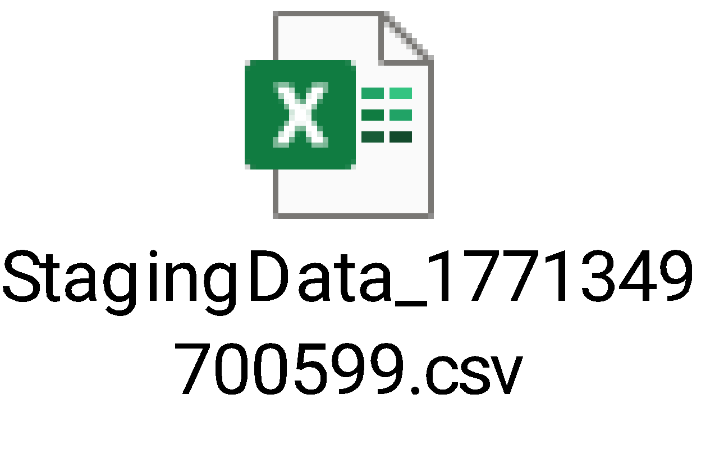
- VC_COMPANY_DETAILS
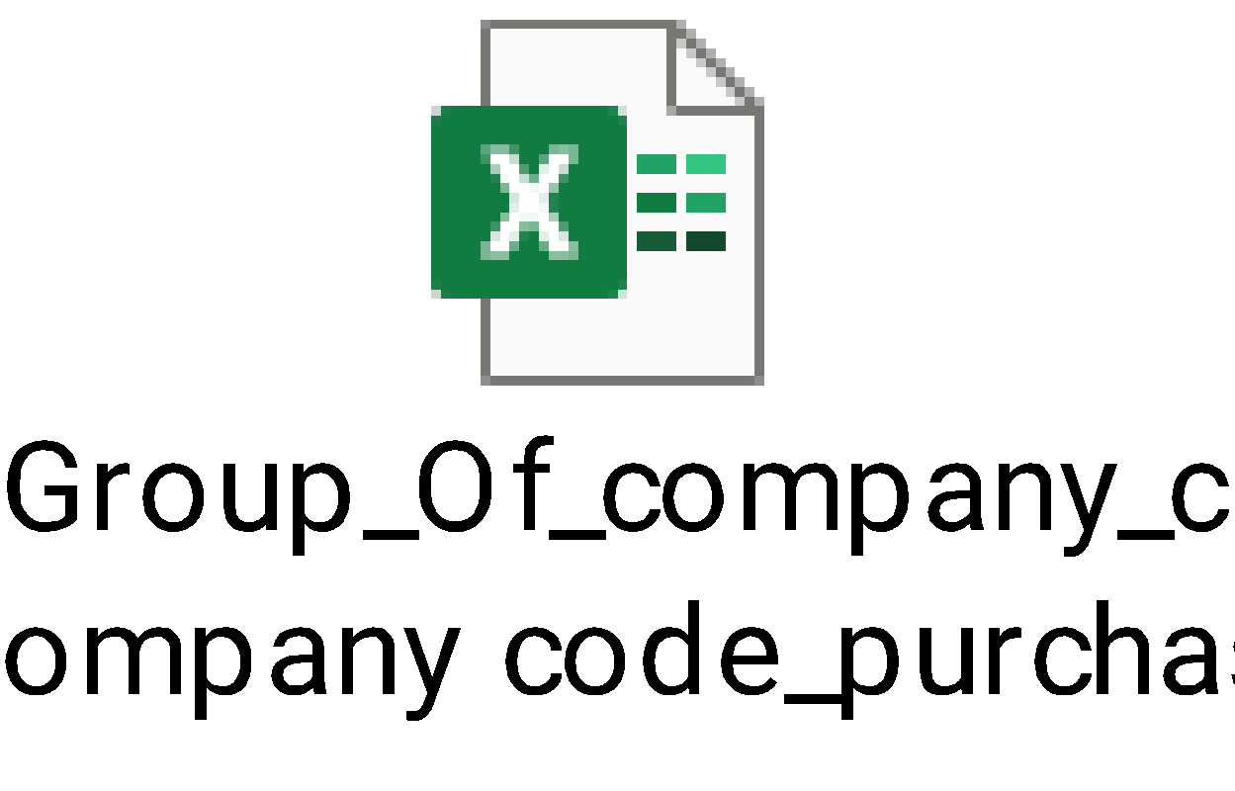

- VC_BANK_DETAILS
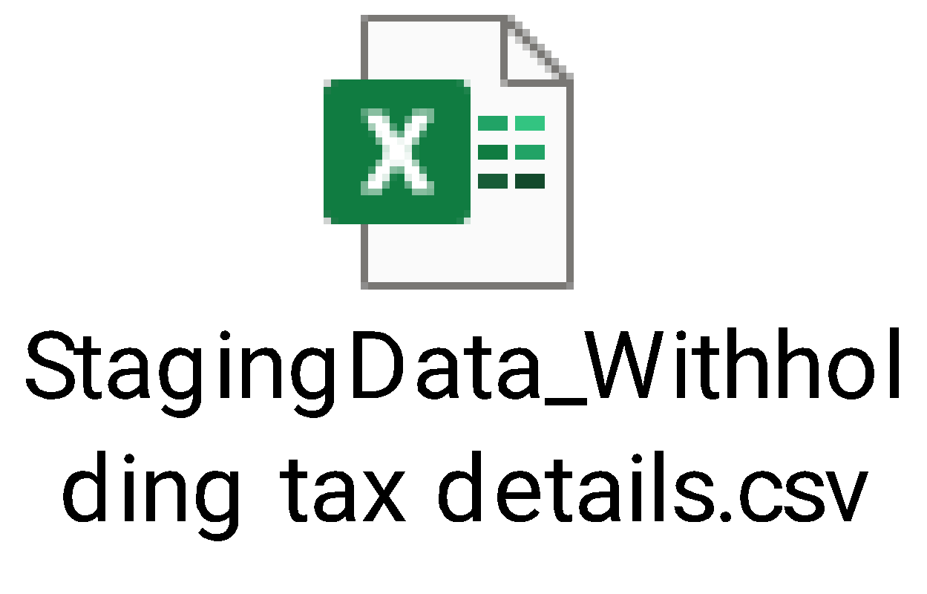

- VC_CIN_DETAILS
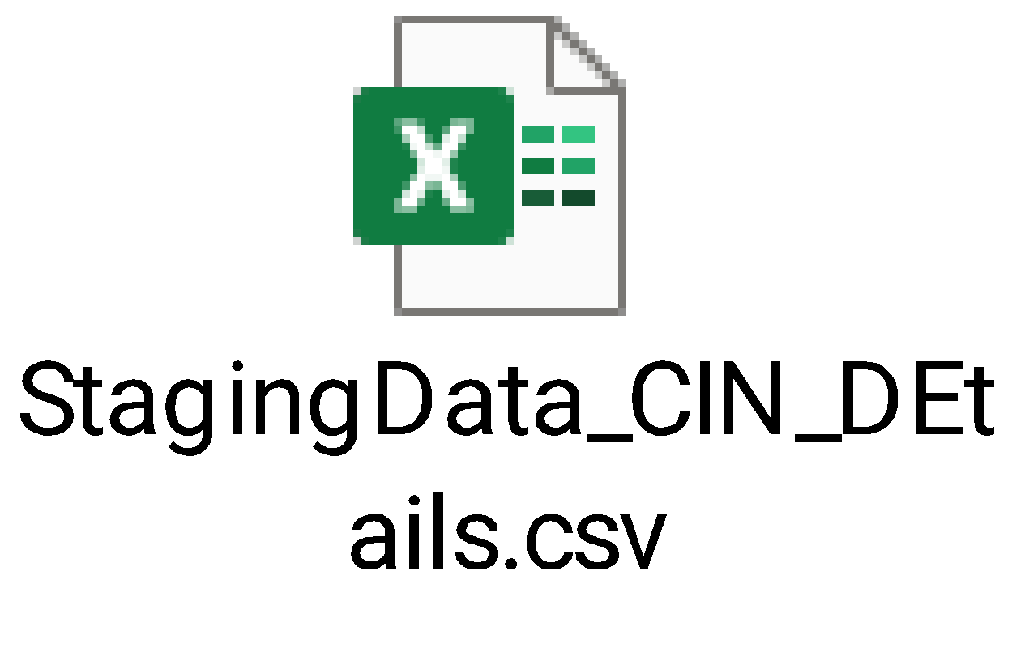
- VC_ADDRESS_DETAILS
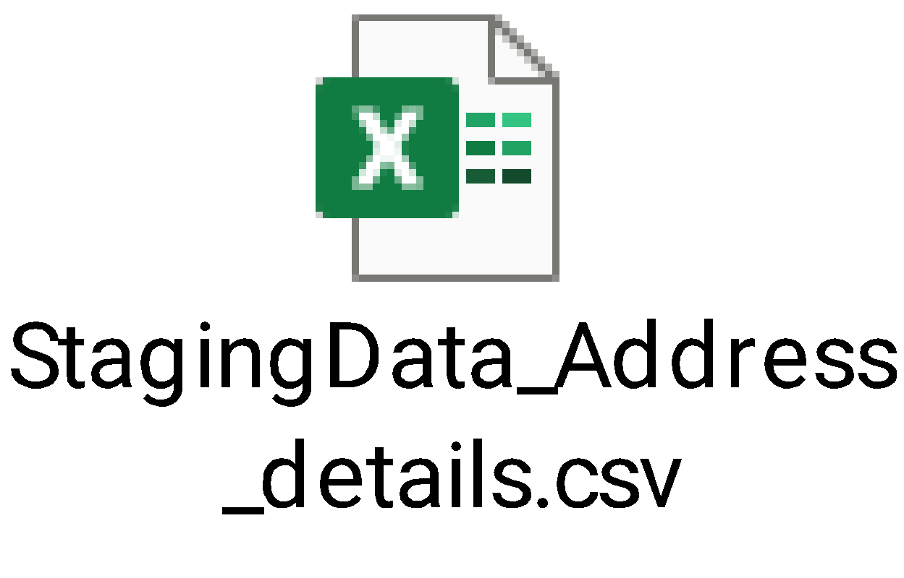

- VC_PURCHASE_DETAILS
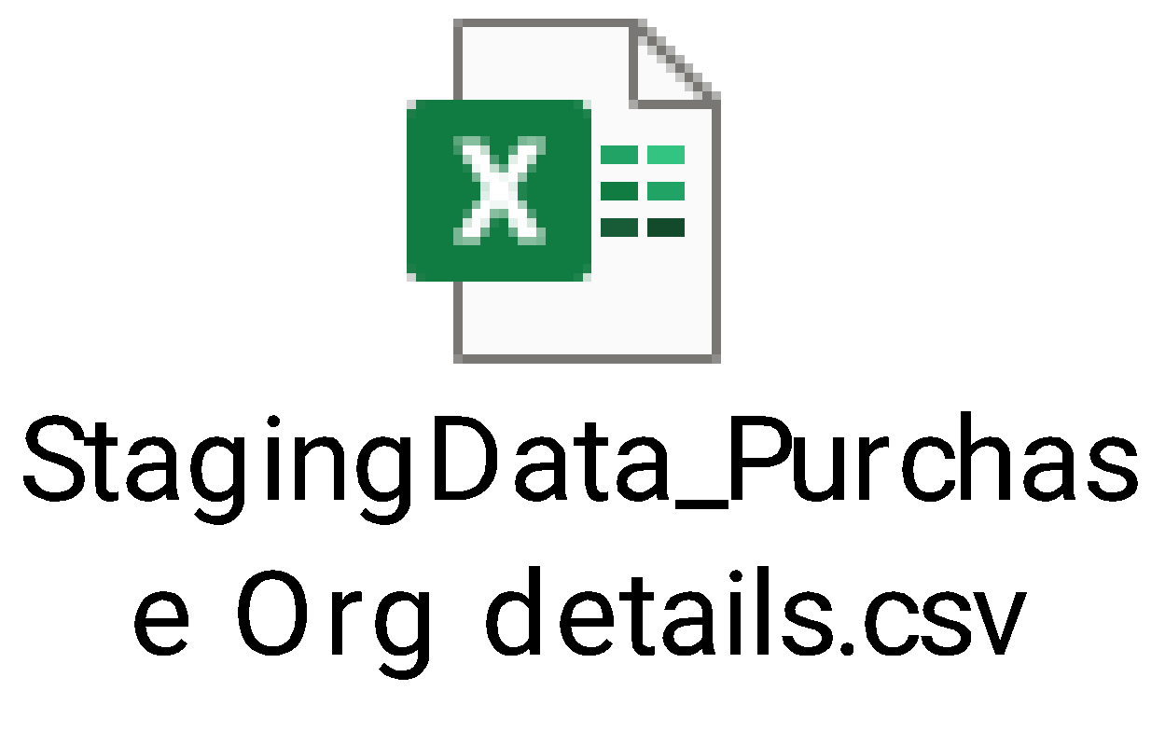

- VC_EMAIL_DETAILS

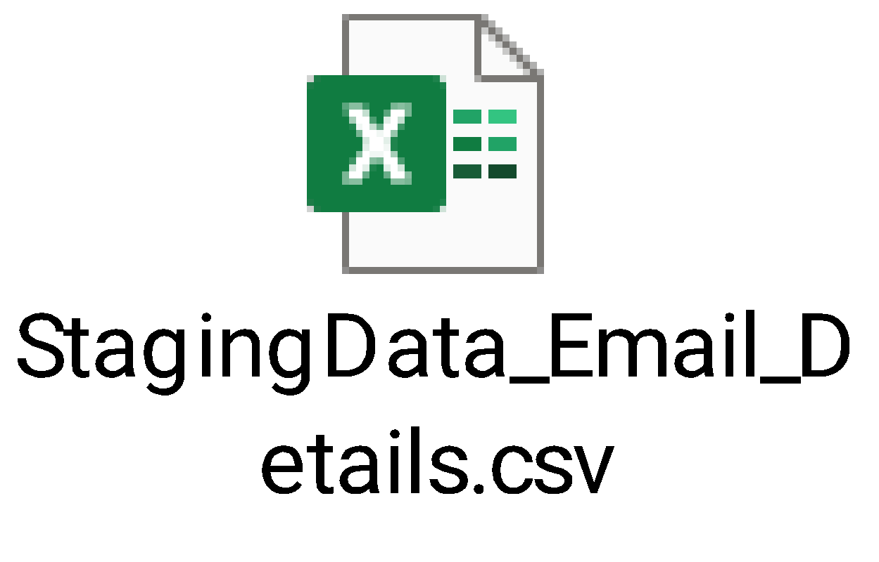
- VC_COMPANY_DETAILS
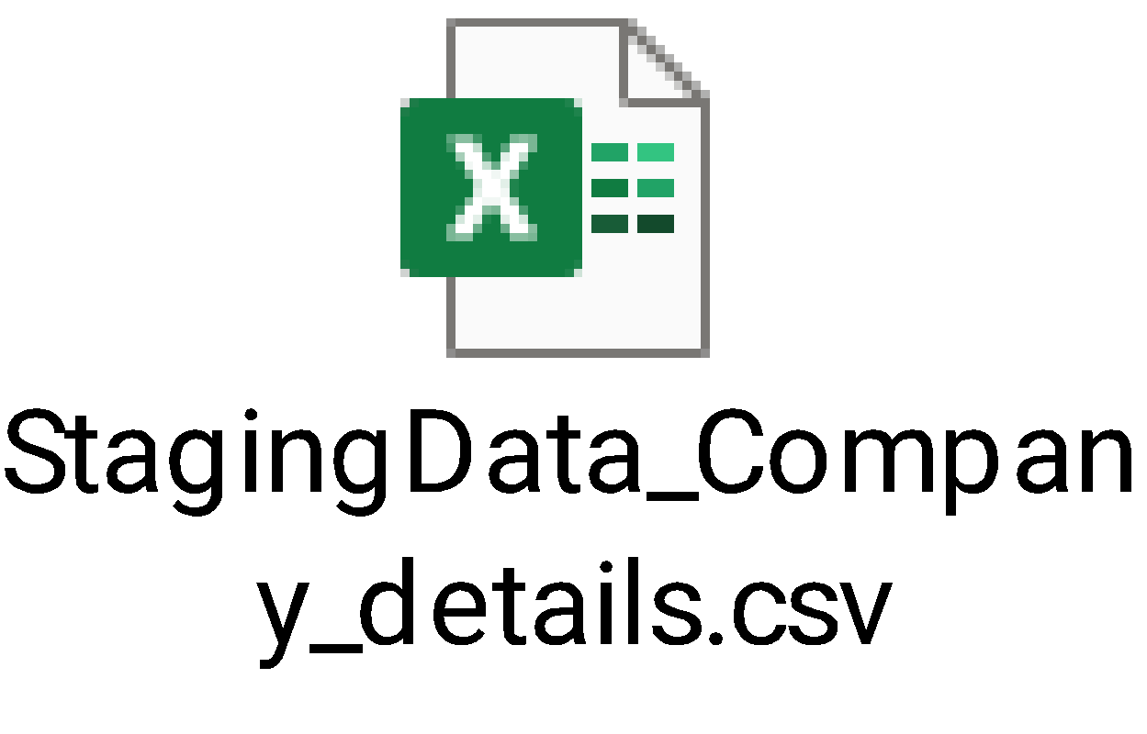
- VENDORFLOWAPPROVERLOGICUPDATE
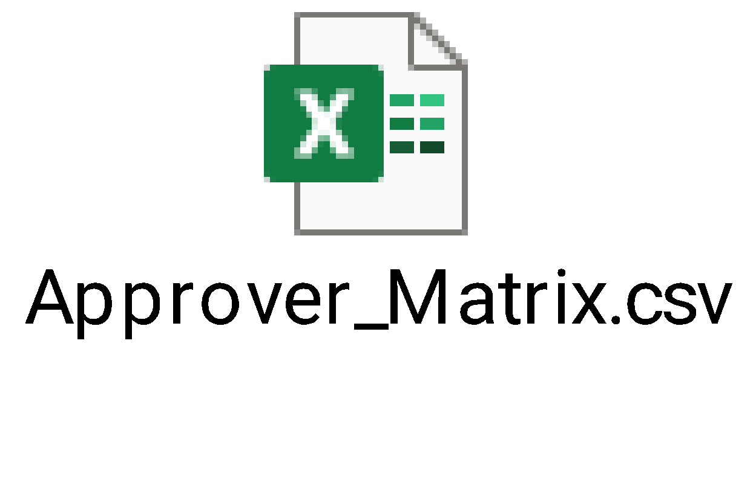

- COMPANY_CODE_PURCHASE_NEW
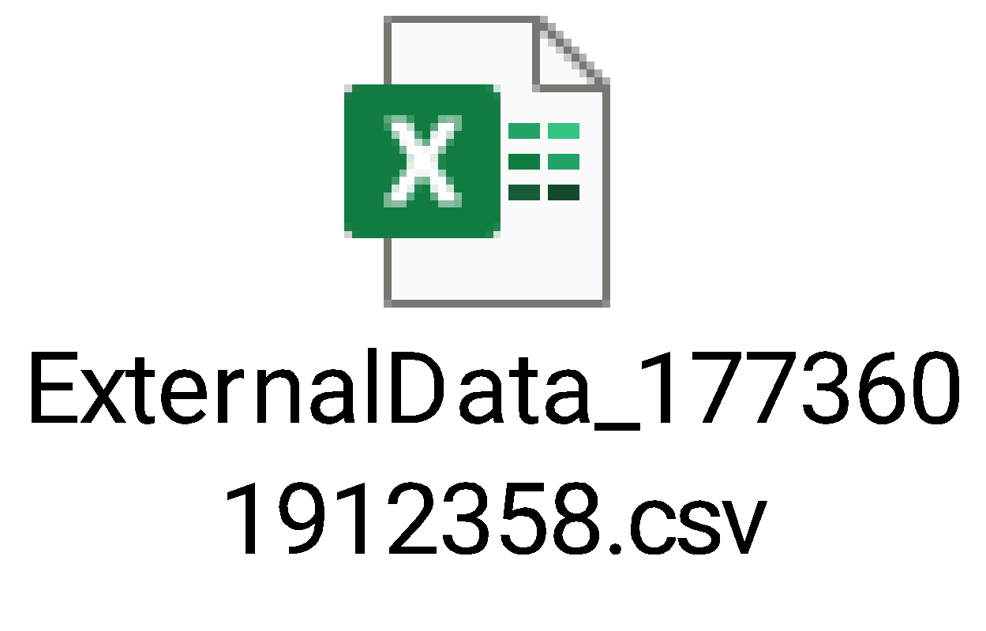

- CURRENCY_COUNTRY
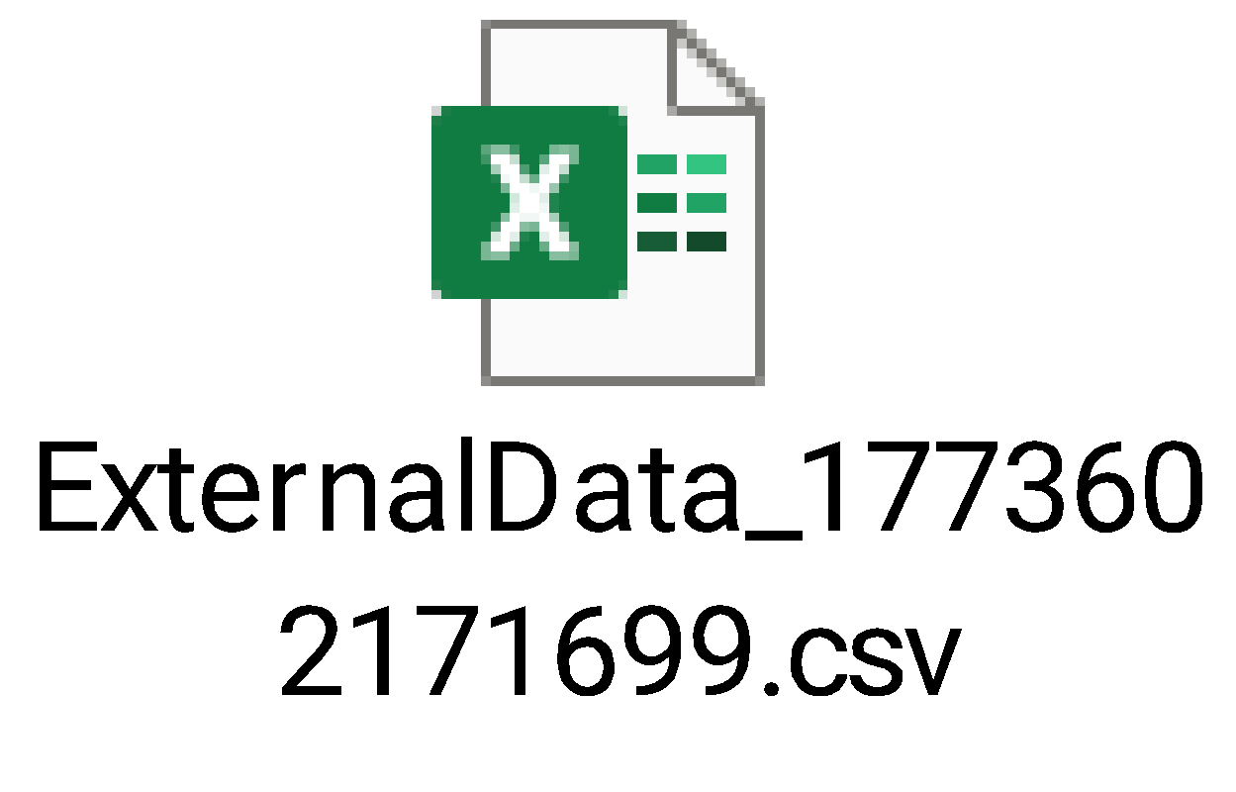

- TERMS_OF_PAYMENT
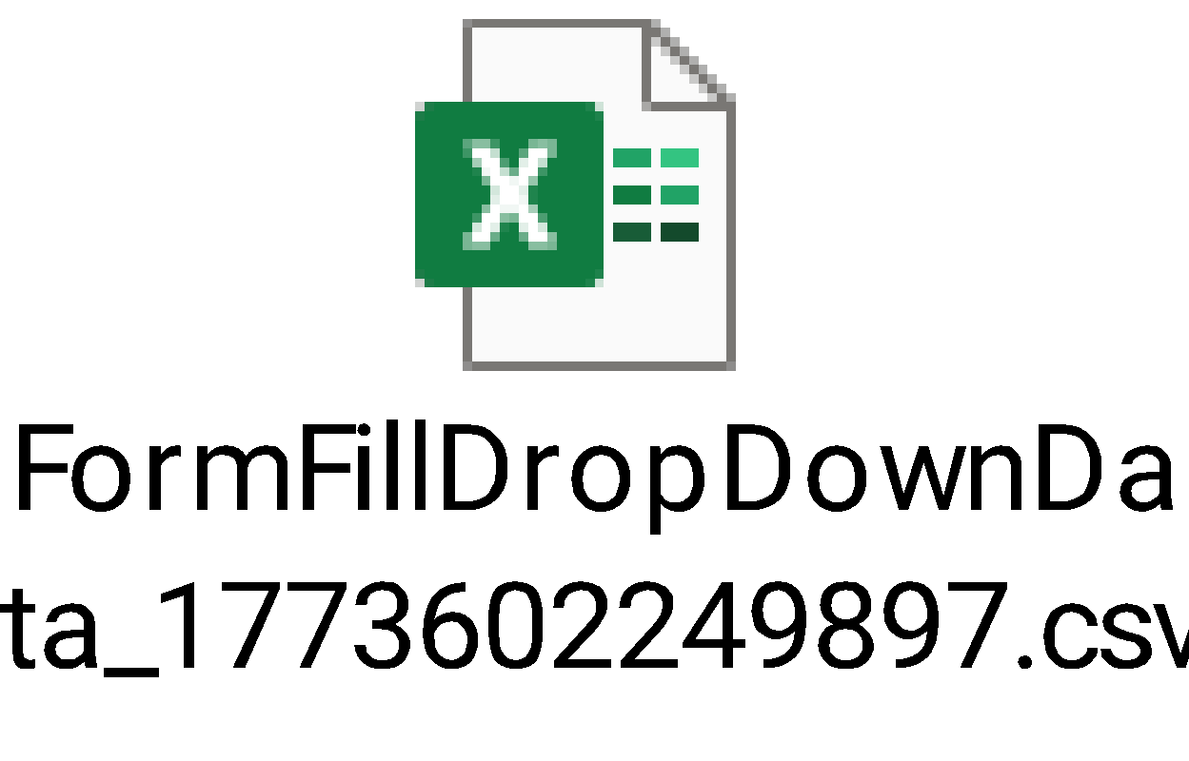
- INCOTERMS
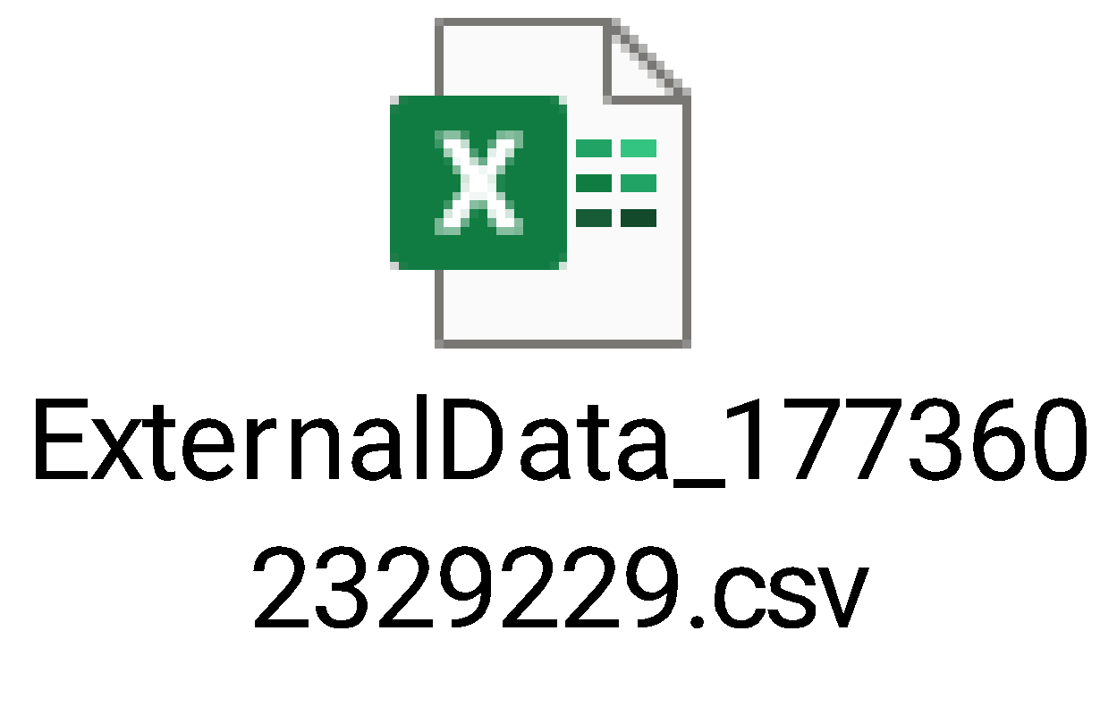

- ADHOC_APPROVER
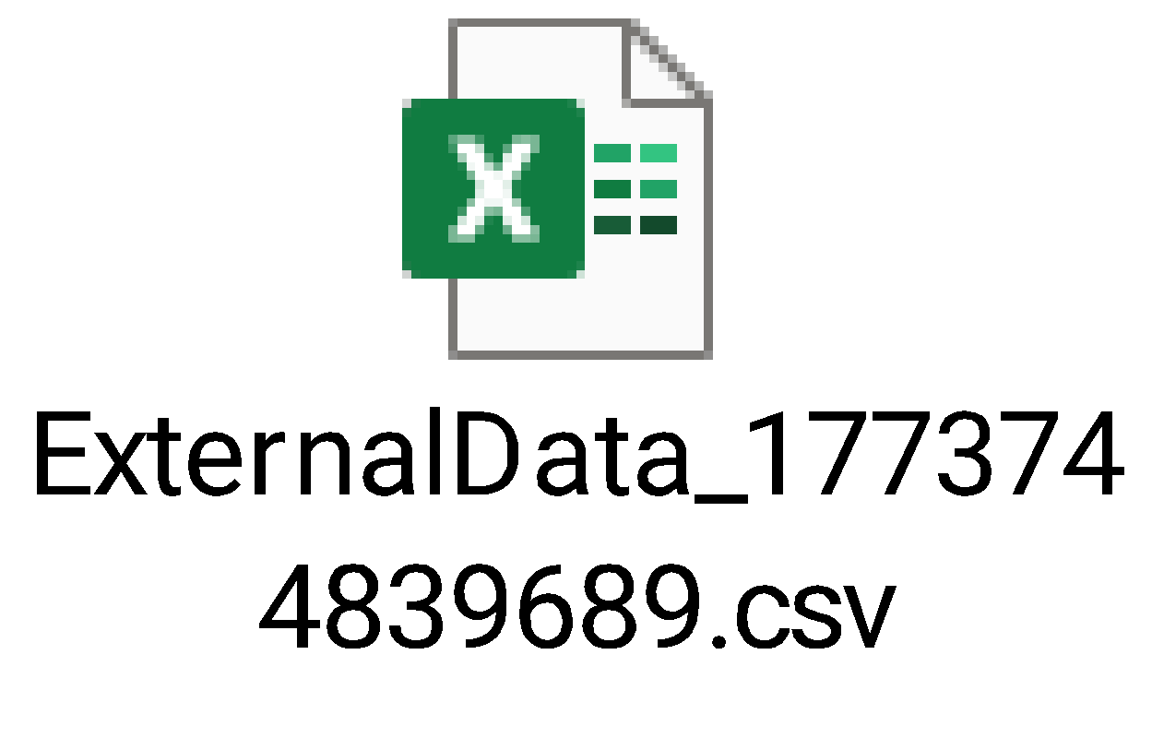
- VENDORFLOWAPPROVERLOGICUPDATE
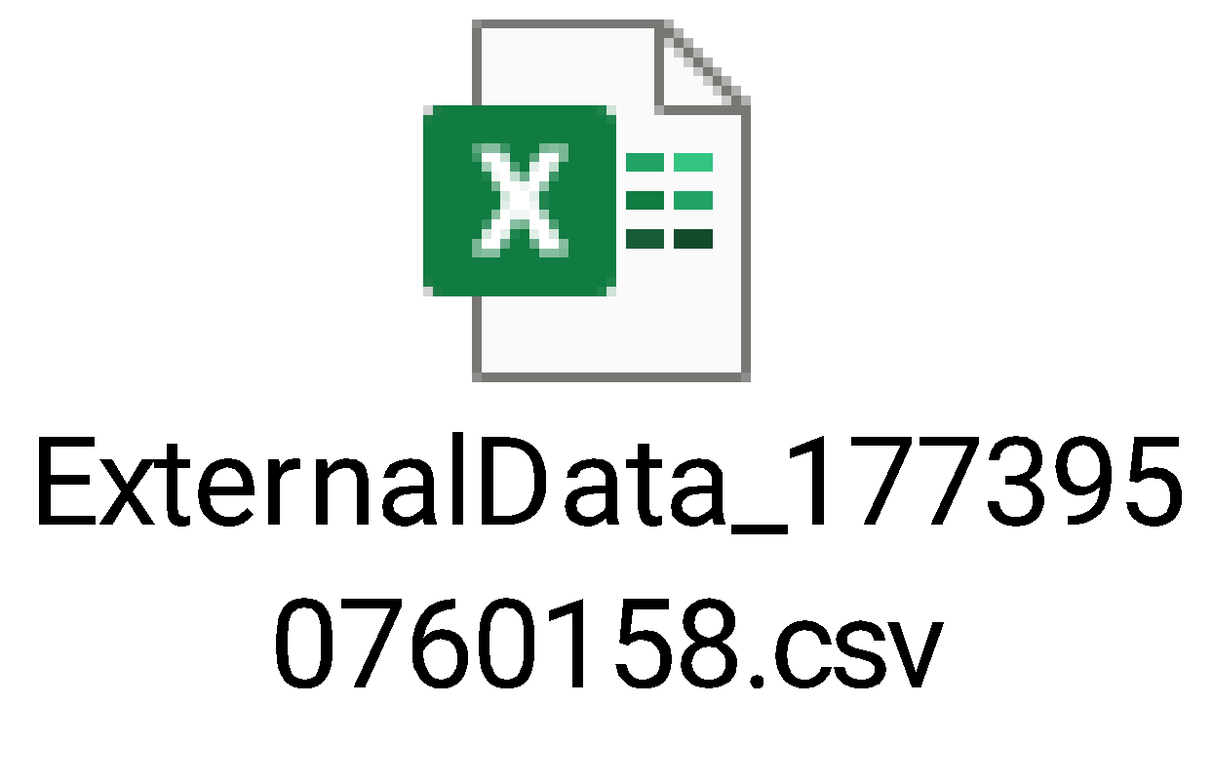
- TERMS_OF_PAYMENT
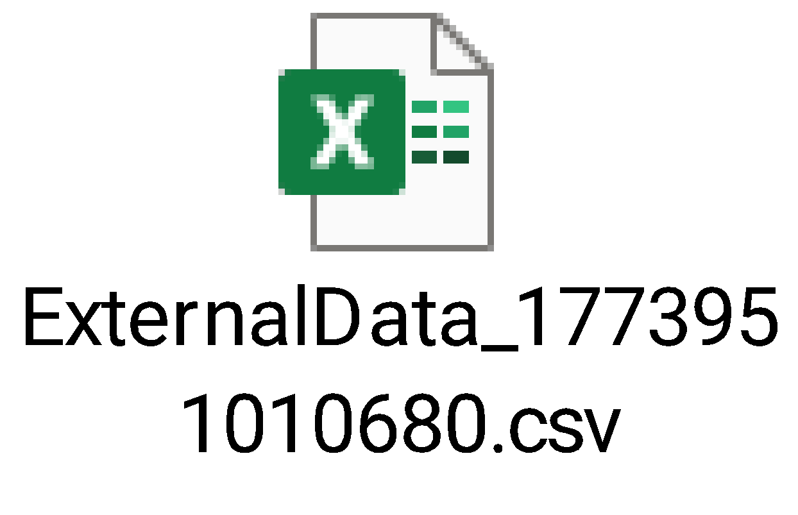
- PINCODE_DETAILS_NEW
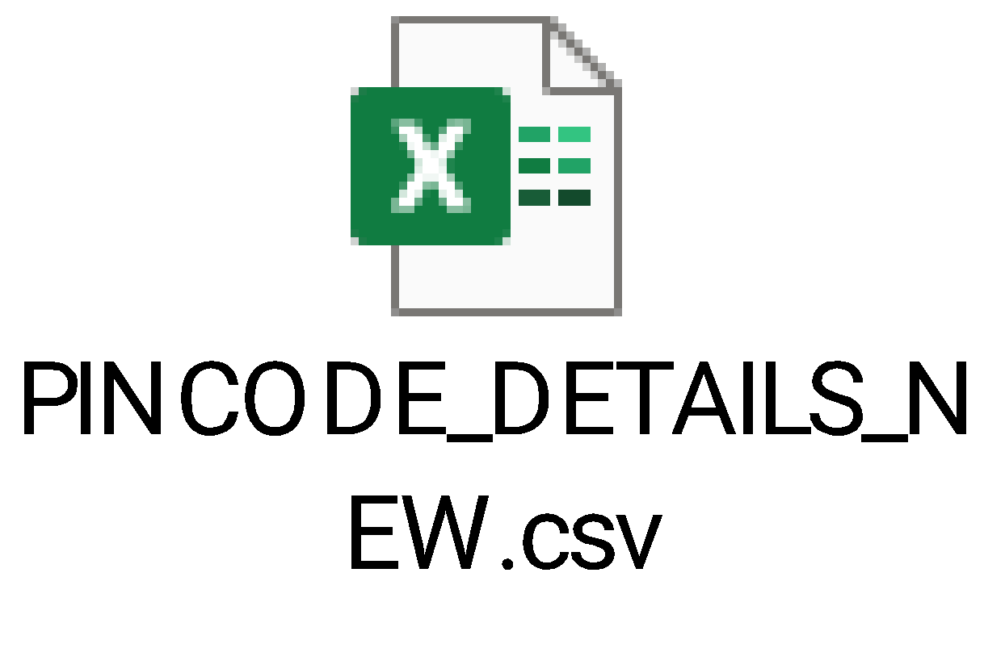
- GSTVALUE
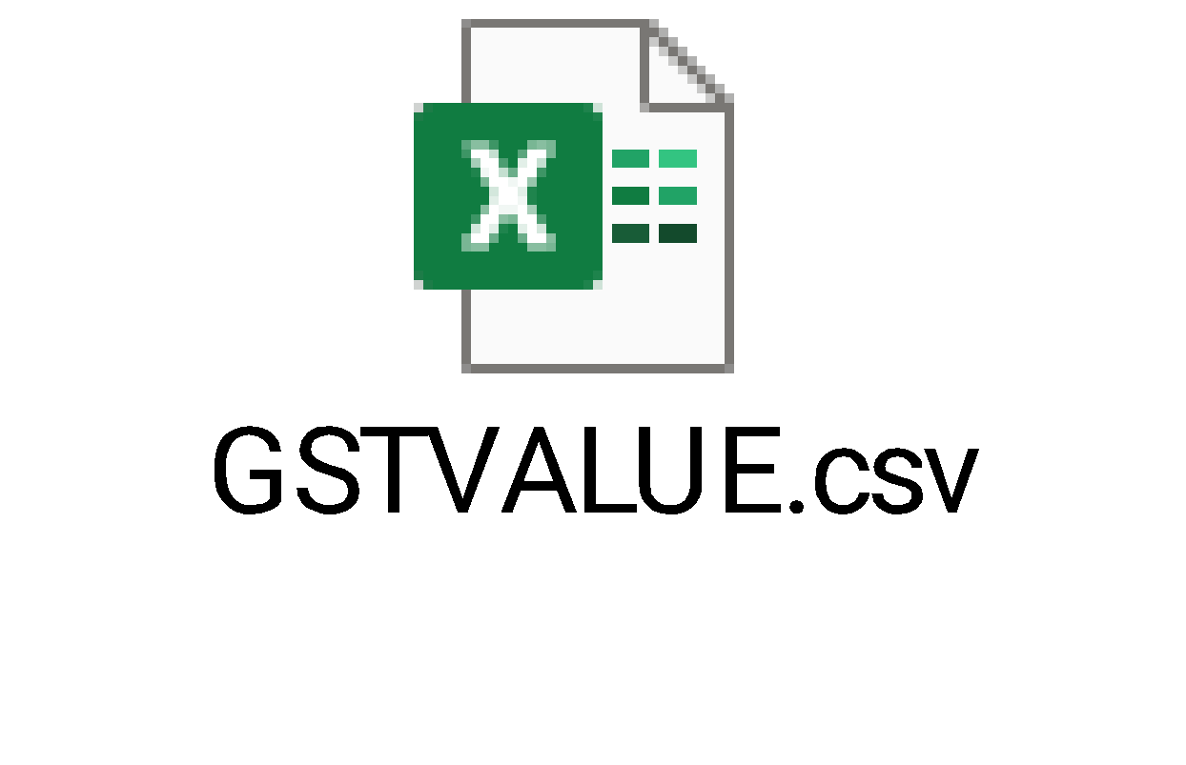

BANK_OPTIONS

- RECONCILIATIONACCOUNTNEW

- COMPANY_CODE

- PIDILITE_WITHHOLDING_TAX

4.7 Record List View
List key fields to be displayed on user/admin dashboards for quick reference.
It will have below mentioned columns.
- Initiator view: The initiator dashboard presents a limited set of configurable columns, along with filter and search options. The dashboard layout is designed according to logic that identifies unique requests, enabling users to perform role-based actions.
Company level Dashboard has Transaction ID,Company Name,Process Name,Vendor Code,SAP Code,CreatedBy,Status.
Template level Dashboard has Transaction ID,Company Name,Process Name,Vendor Code,SAP Code created Date,Vendor Name,CreatedBy,Name of the organization,Status.

4.8 MASS VENDOR UPDATE THROUGH BULK DATA UPLOAD

- Requestors will have the option to raise vendor update requests as initiator only.
- Once this upload is done, the system will create individual vendor update requests and trigger email links to vendor partners as self service.
- The remaining process will be similar to a single vendor update as outlined above in the document.
- Requestor can download an excel template file and input the Vendor details in multiple rows for multiple(mass) vendor updation.
  - Excel format: Pidilite team to provide the format. Need discussion.

- This excel file can be uploaded in Manch where it will create unique requests for each row of vendor data similar to the individual requests and will run all the validations as mentioned in Vendor Updation process.

4.9 Communication Requirements
Effective communication is pivotal to the success of the vendor creation process. This section delineates the communication strategies, channels, templates, and protocols to ensure timely and accurate information dissemination among stakeholders.

4.9.1 Communication Channels
Identify and utilize appropriate channels for different types of communication.:
- Email: For formal notifications, approvals, and escalations.
Email Content:

Subject: On behalf of Pidilite Transaction ID () - Request to Approve the document |Title: Vendor Creation for Name of Organization

The Vendor Master request has been successfully approved and is currently undergoing the next steps in the workflow. Please see the details below:
Request Summary:
Type: Vendor Update Request
Vendor Name:W
Created By: Sonal Joseph
Creation Date:12-04-2026 03:32:02 PM
Transaction ID:xxx
Application Link: Access the Application Click Here
The above data can be viewed using Approver Link The above data can be viewed using Approver Link
Thanks,
Pidilite Industries Limited

4.10 Reporting Requirements
To be discussed with The Pidilite
Specify reporting needs, including:
- Types of reports (e.g., dashboards, TAT reports etc.)
- Data derivation logic
- Access controls

4.11 Integration Requirements
To be discussed with The Pidilite

4.11.1 Integration Overview
- Integration Objectives: Define the purpose of each integration, such as data synchronization, real-time updates, or batch processing.
- External Systems Involved: List all third-party systems, applications, or databases that will interface with the process.
- On the final step of the approval Manch will trigger an SAP integration. Manch will create a payload having all the details as per the mapping table (Separate exercise of this has to be performed by Pidilite team and share with Manch) which will interface and write the data with SAP through API calls and will bring back the feedback in Manch. Basis this feedback Manch will update the requests and close. The status of the requests as “ACCEPTED” to be treated as the closure of the requests and end of the process.
The interface efforts from SAP side to be taken care by Pidilite team.

5. DEPENDENCIES AND QUERIES
- Customized email content to be sent for vendor notification.
- Customized email content to be sent for approver notification.
- Basic details panel Highlighted fields to check should we add in stagging Data

6. Appendix
Include supplementary materials such as process diagrams, data models, or detailed analyses that support the BUD.
Mandatory Guidelines for Document Writing

- Formatting Best Practices:
- Consistent Numbering: Implement a hierarchical numbering system (e.g., 1, 1.1, 1.1.1) to clearly differentiate between sections and subsections.
- Styles and Formatting: Adopt consistent heading styles and formatting to enhance readability and project a professional image.
- Table of Contents: Automatically generate a table of contents based on heading styles to ensure effortless navigation.
- Version Control: Always include version numbers and revision dates to effectively track changes over time.
- Review and Approval: Enforce sections for stakeholder review and approval to guarantee alignment and secure necessary sign-off.

7.TO BE CONSIDERED IN PHASE TWO
The set-up will be configured to allow the Vendor Change flow to the extent possible. If there are any additional or new requirements which cannot be readily supported via configuration, i.e., are part of ongoing development pipeline or to be discussed for development feasibility. We have listed those items here for your reference.
- Request level chat window available for any query rather than send back request at any stage of approval
- Auto cancellation of request of requester not submit the request or approver more than 90 days.
- Reactivation of auto cancellation request rights should be available to MDC team
- SLA based system behavior.
- Delegation Feature.
- Language converter support.
- Vendor Link validity should be 72 hours.

